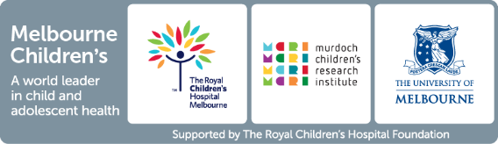

Healthy Trajectories Child and Youth Disability Research Hub Seed Funding – Application Form
Before completing your application, please read the information in the Seed Funding Information Pack. You can download the pack from the MDI website.

Submission
The application process is being administered by the Melbourne Disability Institute. Applications should be submitted by emailing a completed application to MDI General Manager Kirsten Deane at kirsten.deane@unimelb.edu.au. Please mark your email clearly that the application form is for the Healthy Trajectories seed funding round.

Application Instructions
Applications need to address items 1-10 below, be submitted in a Word or PDF document and be no longer than 2500 words. Please note that questions 1-3 and 10 are excluded from the word count.

- Project title
- Lead researcher
Name/title/affiliations/contact details/expertise relevant to this project.
- Other team members
Name/title/affiliation/expertise relevant to this project.
- Summary
Provide a brief overview of the project written in plain English. (300 words)
- Significance
What research priority is being addressed, and how this project will contribute outcomes for children and youth with disability and their families. (300 words)
- Project description
Include a background to the issue, aim, research questions, methods, intended outcomes, and an overview of timelines. (1000 words)
- Team
Approach to co-design and inclusion; team diversity and capability; how the team will work together. (300 words)
- Planned outcomes
How the knowledge gained will be used; plans for sustainability (e.g., future funding, implementation actions. (400 words)
- Budget and justification. (200 words)
- References

