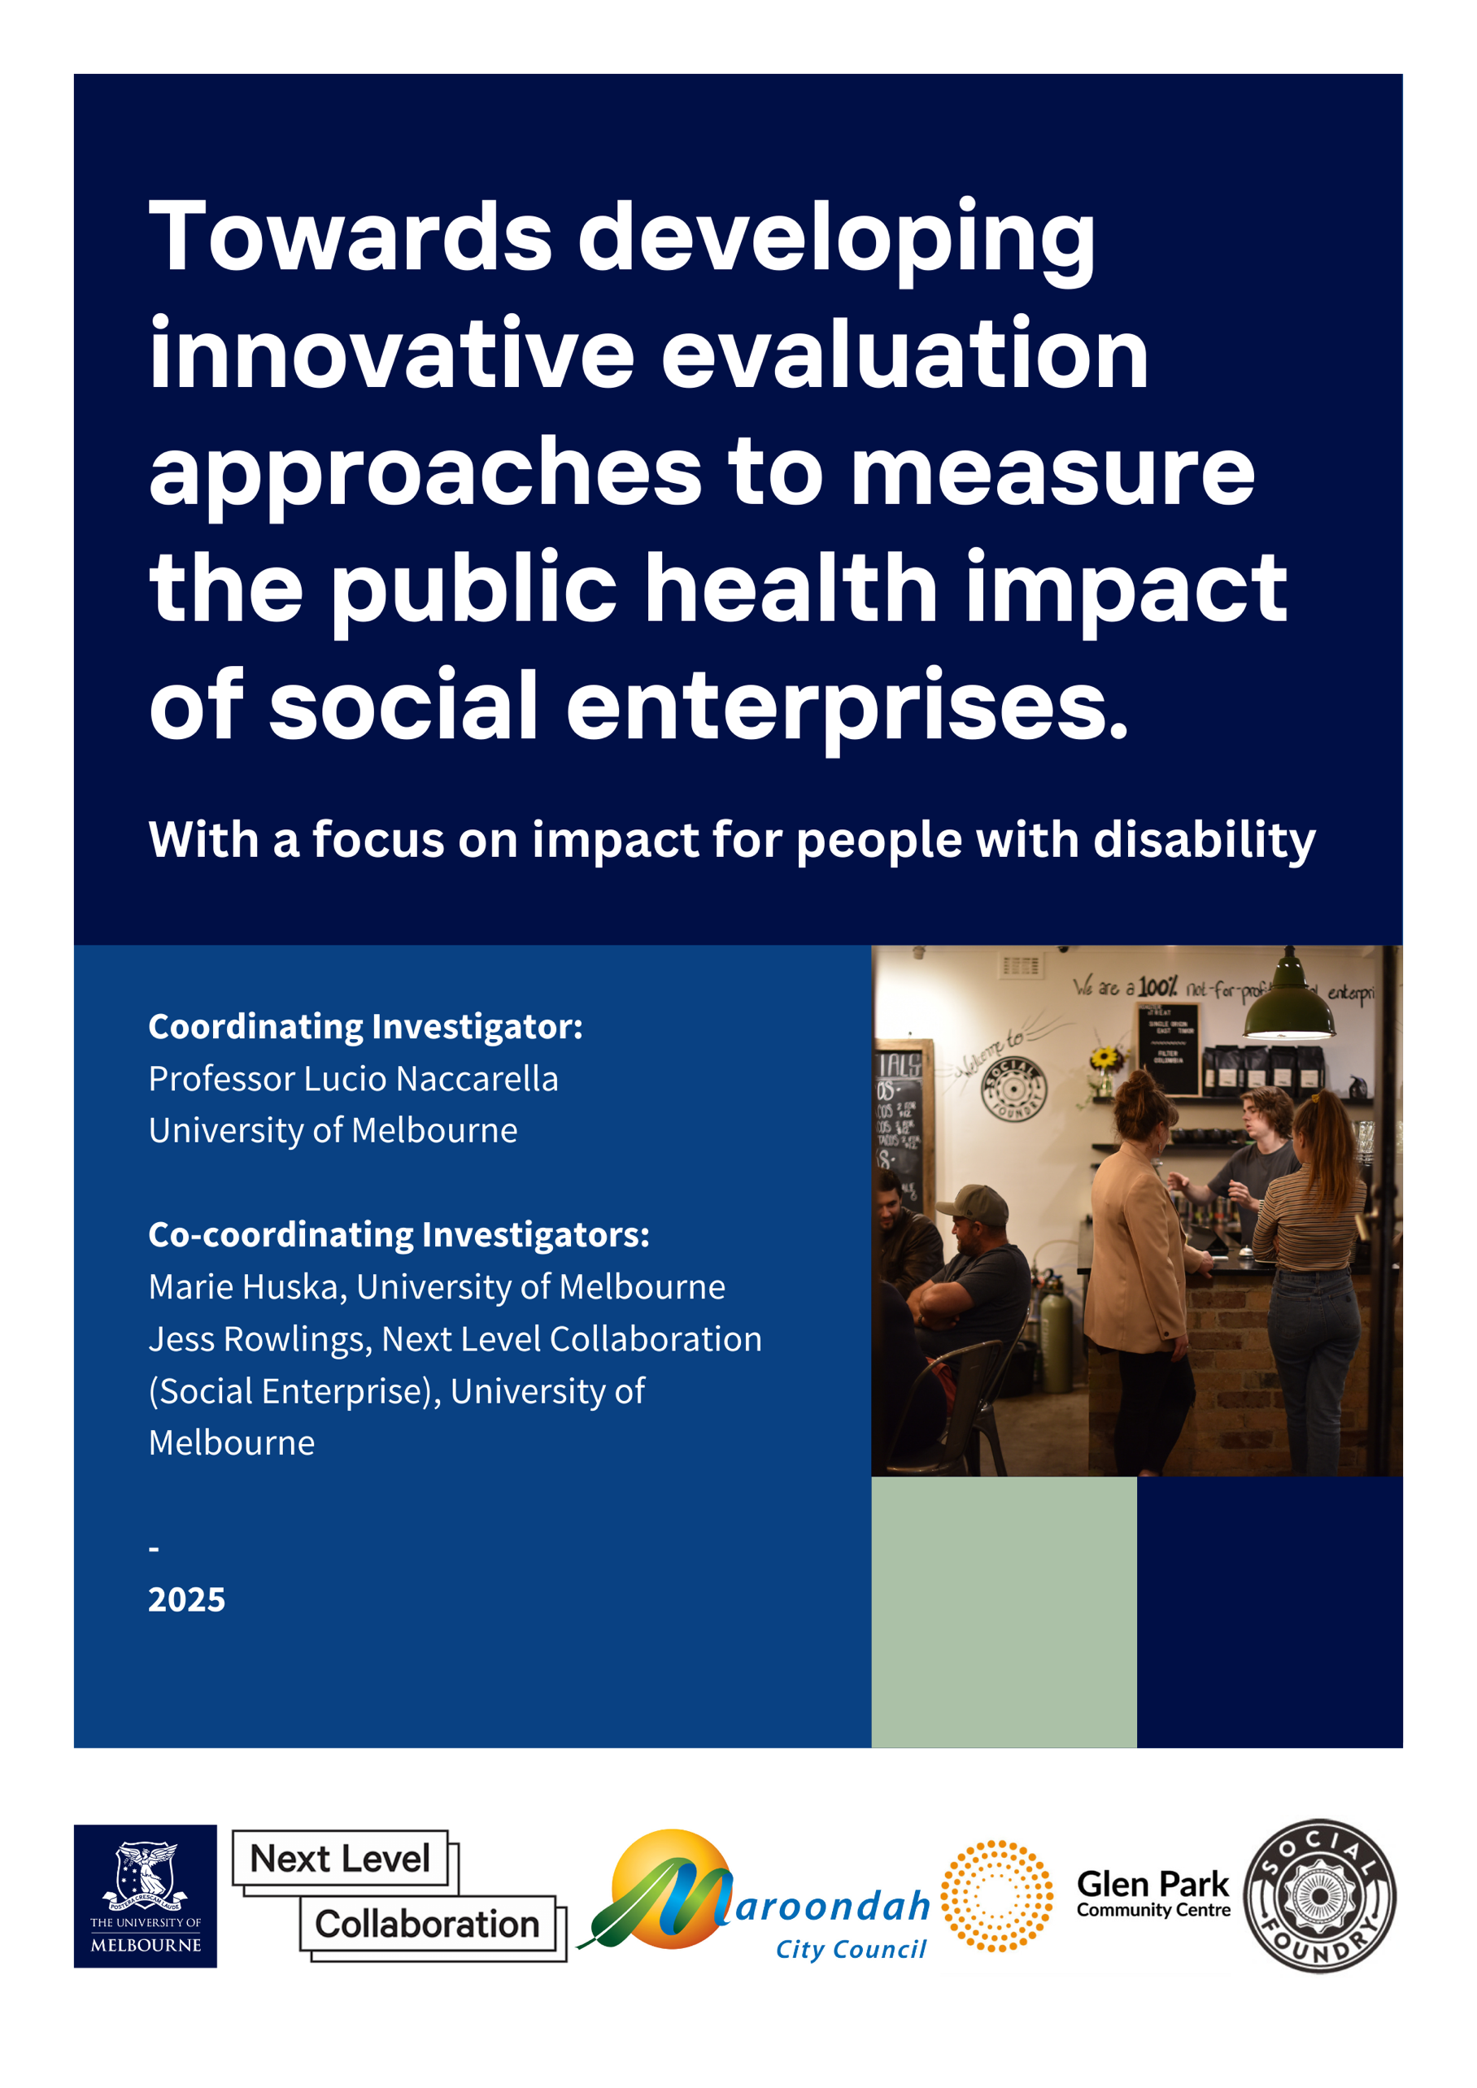

Acknowledgments
We acknowledge the Traditional Owners of the lands and nations on which this project was implemented and pay our respects to the Elders past, present and future. We acknowledge all Aboriginal and Torres Strait Islander peoples who were involved in this project and pay respects to their families, kin and country across Australia.
This project was funded by the Melbourne Disability Institute. The contents presented, however, are of the participants and project team and do not necessarily reflect the views of the funder.
Project Team
Coordinating Investigator:
- Professor Lucio Naccarella, University of Melbourne
Co-coordinating Investigators:
- Marie Huska, University of Melbourne
- Jess Rowlings, Next Level Collaboration (Social Enterprise), University of Melbourne
Co Investigators:
- Heidi Butler-Moore, CEO Glen Park Community Centre, Café on the Park (Social Enterprise)
- Chris Riseley, Maroondah City Council
- Sue-Lee Theel, Social Foundry (Social Enterprise)
- Dr. Alexandra Devine, University of Melbourne
- Associate Professor Sue Olney, University of Melbourne
- Associate Professor Matt Harrison, Next Level Collaboration (Social Enterprise), University of Melbourne
- Dr Jemimah Ride, Monash University
Advisory Group
- Professor Jo Barraket, Director of the Melbourne Social Equity Institute
- Professor Rob Carter, Chair in Disability Economics, Melbourne Disability Institute
- Dr Kate Barrelle, C-founder & Chief Impact Officer STREAT (Social Enterprise)
- Dr Andrew Joyce, Senior Research Fellow, Centre for Social Impact Swinburne
Suggested Citation
Huska, M., Rowlings, J., Devine, A., Olney, S., Harrison, M., Ride, J., Butler-Moore, H., Theel, S., Naccarella, L. (2024). Towards developing innovative evaluation approaches to measure the public health impact of social enterprises. With a focus on impact for people with disability. Melbourne: The University of Melbourne.
https://doi.org/10.17613/sg102-bxg77
Contact
Professor Lucio Naccarella, University of Melbourne: l.naccarella@unimelb.edu.au
Table of Contents
Acknowledgments 2
Executive Summary 5
1. Introduction 8
1.1. Background 8
1.2. Social Enterprise and the ‘wellbeing economy' 8
1.3. Social Enterprise in Australia 9
1.4. Research and Evaluation of Social Enterprises 9
1.5. Research to understand current evaluation approaches 10
2. Methods 12
2.1. Study design 12
2.2. Ethics 13
2.3. Key Stakeholder consultations 13
2.3.1. Phase one consultations 14
2.3.1.1. Analysis 14
2.3.1.2. Results 14
2.3.2. Phase two consultations 16
2.4. Narrative Review 19
2.4.1. Search strategy 19
2.5. Results of Narrative Review 20
2.5.1. Selection of literature 20
2.5.2. Characteristics of included literature 22
2.5.3. Quality Assessment 29
3. Synthesis of Stakeholder Consultations and Literature Review Results 31
3.1. Social enterprise Context 32
3.1.1. Characteristics of the Social Enterprise 32
3.1.2. Characteristics of the community within which a Social Enterprise is situated 35
3.1.3. Characteristics of the broader political and economic environment in which the Social Enterprise operates 36
3.2. Measuring and communicating social outcomes/impacts 37
3.3. Challenges in capturing the public health impact(s) of social enterprises 38
3.4. Leveraging 38
3.5. Capacity building 38
4. Discussion 40
5. Strengths & limitations 43
6. Conclusion 45
References 47
Appendix 51
Appendix 1: Critical Appraisal Checklists 51
Appendix 2: Focus Group Participant Consent Form 55
Appendix 3: Focus Group Participant Verbal Consent 56
Appendix 4: Interview Participant Consent Form 58
Appendix 5: Research Flyer Template – Focus Group Participants 59
Appendix 6: Research Flyer Template – Interview Participants 60
Appendix 7: Plain Language Statement 61

Tables and figures

Table 1: Focus group characteristics 13
Table 2: Phase 1 stakeholder consultation key themes and sub-themes 15
Table 3: Phase 2 stakeholder consultation identified gaps and opportunities 17
Table 4: Inclusion and exclusion criteria 19
Table 5: Ovid Medline, SocINDEX and CINHAL search terms 19

Figure 1: Flow diagram of literature selection process 20

Executive Summary
Over the past decade, emerging evidence has identified the potential role of social enterprise in addressing health inequalities. Embedding social impact into the core organisational structure to achieve their social mission, social enterprises work to directly address a social need through business activities that fund their operational expenses. However, diversity within the missions of social enterprises has led to a diversity of approaches to their evaluation. The ways in which social enterprise may impact on the social determinants of health are yet to be fully understood. This project, funded by the Melbourne Disability Institute, aimed to contribute toward understanding current methodological approaches to how individual social enterprises may gather evidence of impact on public health.
This report synthesises key stakeholder experiences of current approaches to measuring and evaluating the public health impact of social enterprises, with a narrative review of current literature examining the evaluation of the public health impact of social enterprises for people who experience health inequities, with our specific focus on people with disability. The synthesis identified a clear need for fit-for-purpose evaluation approaches. We propose priority areas for future research to support development and implementation of accessible and sustainable evaluation approaches, capable of providing consistent and meaningful insights.
Overarching findings
Within stakeholder consultations and the reviewed literature, the overarching narrative conceptualised the potential for social enterprises to positively impact the social determinants of health. Five key themes emerged:
1. Social Enterprise Context
1.1 Characteristics of the Social Enterprise
Social enterprises can play a significant role in integrating people with disability into the labour market, by creating supportive environments that address the physical, social and stigma barriers they experience.
1.2 Characteristics of the community within which a Social Enterprise is situated
The community’s understanding and valuing of the social enterprise are critical. A well-regarded enterprise can attract more support and engagement from local stakeholders. Building strong relationships with the business community, educational institutions, and other key stakeholders can enhance an enterprise’s impact and sustainability but is often challenging.
1.3 Characteristics of the broader political and economic environment in which the Social Enterprise operates
Policies and initiatives, such as the Australian Federal Government White Paper and the Social Enterprise Development Initiative, play a crucial role in supporting social enterprises. These policies can provide funding, resources, and a supportive regulatory framework that enables social enterprises to thrive.

2. Measuring and communicating social outcomes/impacts
Current approaches to measuring and communicating social outcomes and impacts in social enterprises are influenced by the need to balance practicality with rigor. These ad-hoc approaches may not be capturing the full scope of the enterprise’s impact. Measuring outcomes for beneficiaries with disability requires capturing their personal experiences and perspectives.
3. Challenges in capturing the public health impact(s) of Social Enterprises
The inconsistent definition of social enterprise presents significant challenges in capturing their public health impacts. The complexity of their identity and operational models, coupled with the wide range of goals they pursue, makes it difficult to apply uniform measurement and evaluation frameworks.
4. Leveraging
By effectively leveraging existing programs, knowledge, and understanding, social enterprises can enhance their capacity to achieve their social and economic goals.
5. Capacity building
By focusing on capacity building at multiple levels - within individual social enterprises, among external stakeholders, and within the broader community, social enterprises can enhance their ability to achieve their social and economic goals.
Recommendations for future research
- Research examining what characteristics of a social enterprise are required to inform its theory of change, in order that it contributes knowledge of the broader social enterprise sector public health impact, recognising this knowledge development occurs over time requiring longitudinal studies.
- Research examining the development of interpersonal relationships and the experience of role-modelling includes the potential for multidirectional impacts on health and wellbeing outcomes for beneficiaries.
- Research exploring how participation by beneficiaries in identification, measurement and communication of social enterprise impacts contributes to their participation in the social enterprise.
- Research exploring how to support the implementation of accessible and sustainable evaluation approaches that generate consistent and meaningful evaluation evidence.

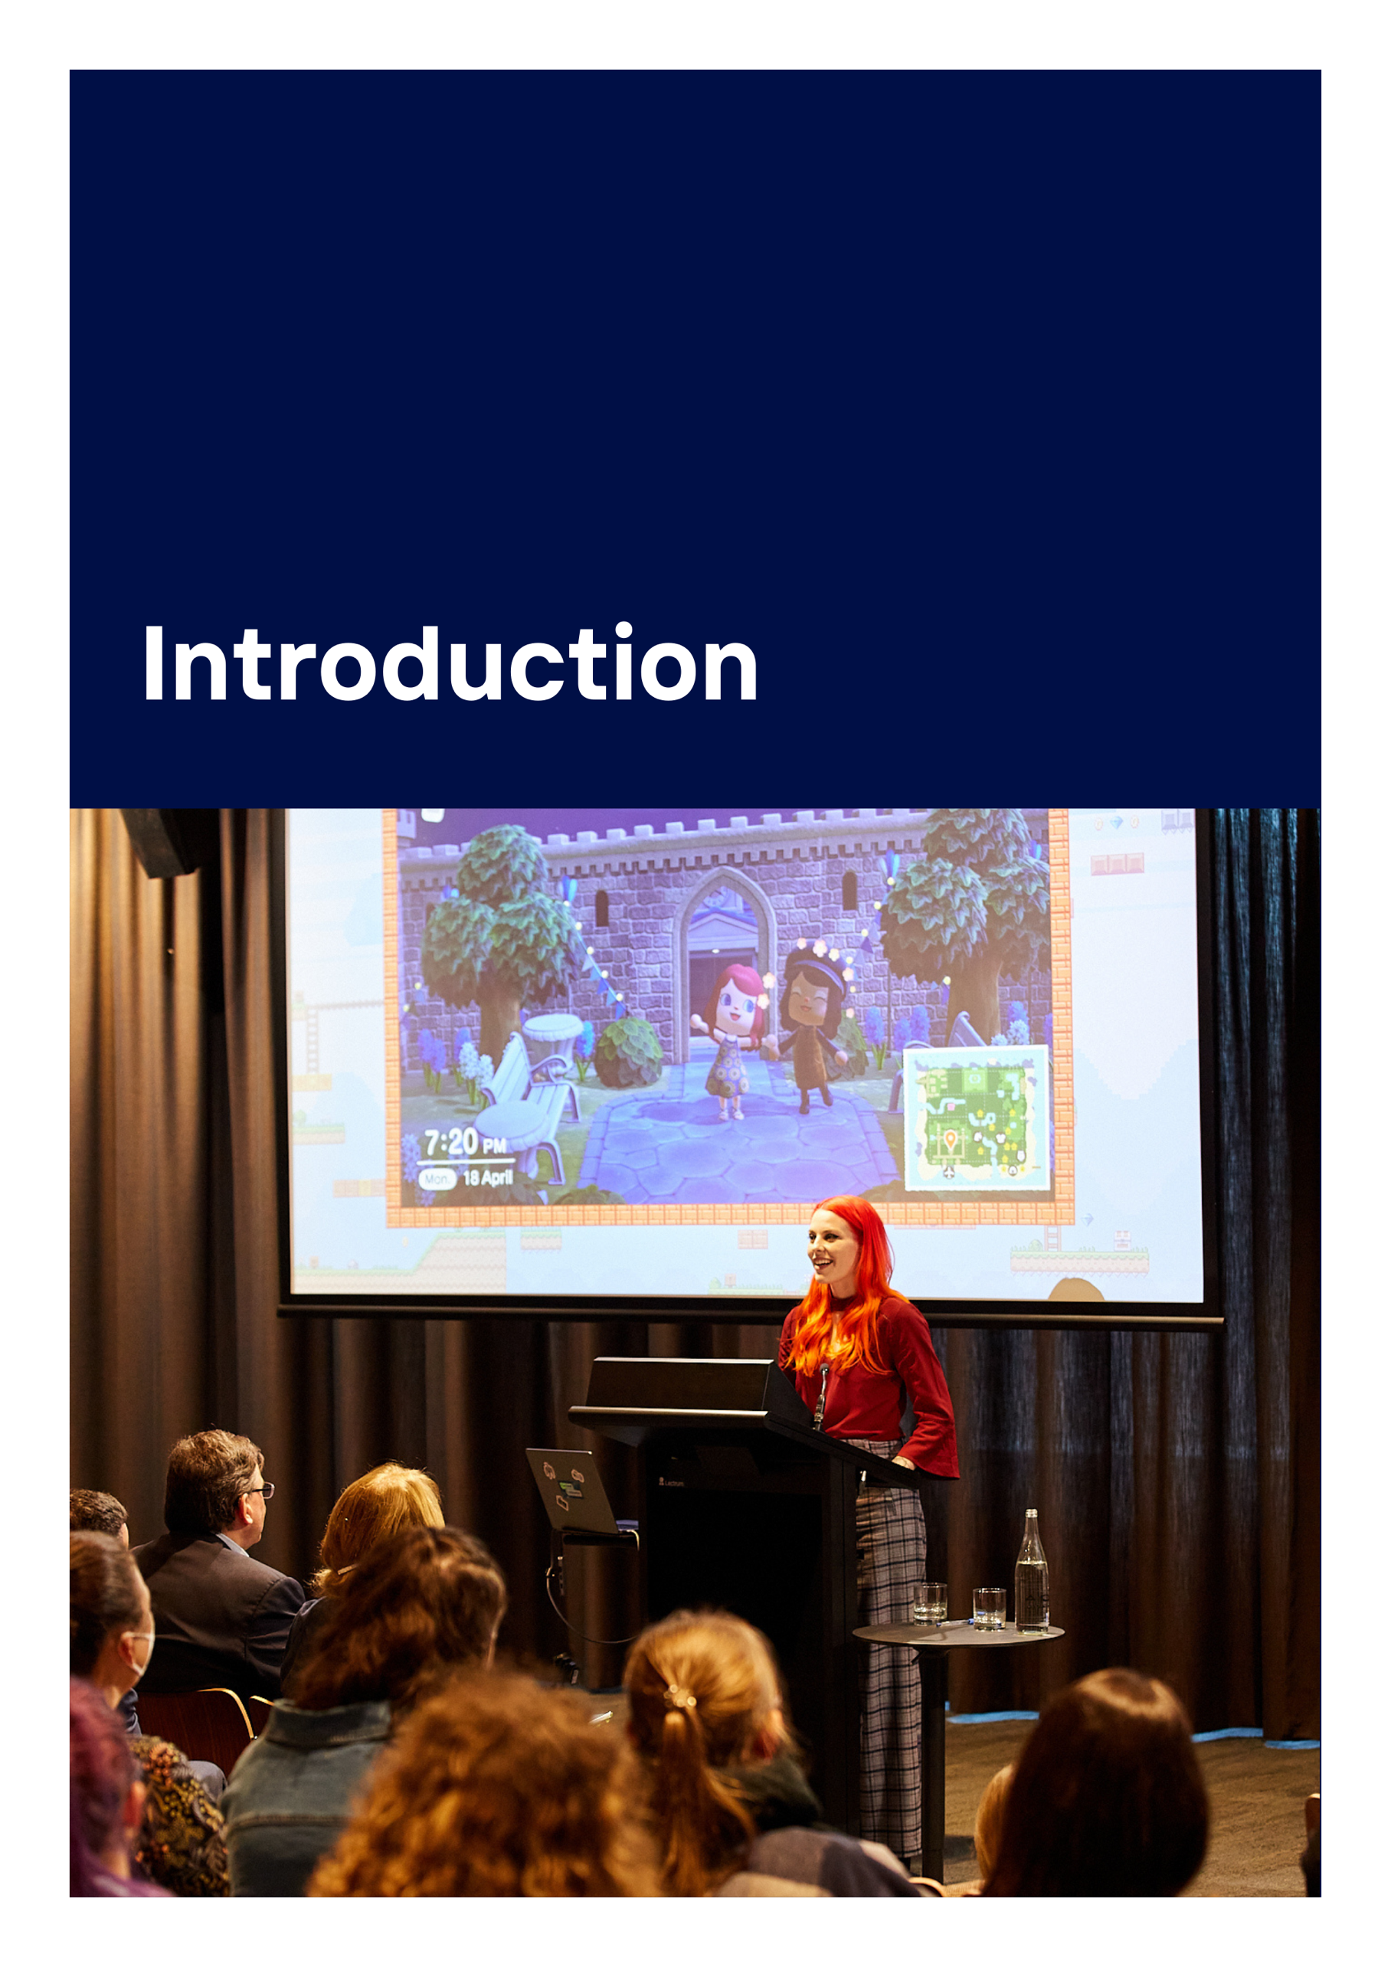

1. Introduction

1.1. Background
Over the past decade, emerging evidence has identified the potential role of social enterprise in addressing health inequalities (Joyce et al., 2022; Macaulay et al., 2018). In general, social enterprise is a business model that focuses on an overarching goal of creating social impact rather than maximising financial returns. While social enterprise shares some commonalities with charities and not-for-profit organisations, there are two key features that define social enterprise (Galvin & Iannotti, 2015). Firstly, social impact is embedded into the core organisational structure by directly addressing a social need through business activities (Social Enterprise Alliance, 2013).
Achievement of this social mission is the primary driving force behind social enterprise, rather than prioritising revenue generation. Secondly, social enterprises fund their operational expenses through business revenue, compared to non-profits who typically function using grant funding, donations, or other subsidies (Social Enterprise Alliance, 2013). While social enterprises may supplement their income with grants or other forms of external funding, these organisations seek to reach financial sustainability through generating profit alone (Nicholls, 2006).
Social enterprise is a new concept that can be considered a product of changes in public service over time. Throughout the 1980s and 1990s, many people left government civil service roles due to rapid growth in the not-for-profit sector. However, the Reagan administration cut government funding for not-for-profit organisations in the United States throughout this period, and generating commercial revenue became necessary to compensate for their reduced government funding (Kerlin, 2010). Other regions including South America and parts of Europe also experienced economic decline, and government social support was either decreased or found to be overall inadequate.
Across all geographic areas, social enterprise has emerged in response to an underlying theme of insufficient social support and/or funding from government bodies (Kerlin, 2010). Some consider social enterprise to be a form of privatisation as the public sector has historically maintained responsibility for addressing healthcare, education, and other social inequalities (Nicholls, 2006). However, arguments have been made that the public sector can be bureaucratic and slow-moving, and public policies do not always reflect what is happening ‘on the ground’ (Bornstein & Davis, 2010). In contrast, many social enterprises focus on flexibility and efficiency along with profitability as measures of organisational performance (Bagnoli & Megali, 2011).

1.2. Social Enterprise and the ‘wellbeing economy'
In a modern context, the developing model of a ‘wellbeing economy’ considers the diverse economic environment required to enable truly inclusive communities (Fioramonti et al., 2022). Under the ‘wellbeing economy’ approach, the concept of value is defined beyond economic factors and instead is considered in relation to collective human and ecological wellbeing (Fioramonti et al., 2022). Although social enterprises commonly focus on addressing employment inequalities for marginalised communities, the concept of a ‘wellbeing economy’ offers a different perspective under which to consider the outcomes and benefits of social enterprise. Examining social enterprise from a public health perspective, for example understanding the impacts on people’s health associated with their economic circumstances, can broaden understanding of the return on investment by considering both the private and public value of the model beyond employment (Shipton et al., 2021). This is especially relevant to people with disability who experience considerable health inequalities in comparison to those without disability (Green et al., 2021).

1.3. Social Enterprise in Australia
In Australia, governments, universities, industries, and philanthropic organisations have increasingly responded to the evidence highlighting the potential of social enterprise as a way to address health inequalities (Glen Park Community Centre, 2020; Harrison, 2022; Victorian State Government, 2021). A growing number of these organisations have established dedicated investment funding or other forms of support for social enterprises (Australian Government, 2023b; Philanthropy Australia, 2023), particularly for initiatives that seek to improve outcomes for populations who are more likely to experience health inequities, including people with disability (Australian Bureau of Statistics, 2018).
The identified Outcome Areas of Australia’s Disability Strategy 2021-2031 reflect the priorities of people with disability and their families in alignment with the social model of disability (Commonwealth of Australia, 2021). The intersection between the potential role of social enterprise to reduce health inequalities and the goals of the Disability Strategy creates an opportunity to better understand whether and how social enterprise can impact social determinants to produce public health outcomes.

1.4. Research and Evaluation of Social Enterprises
Diversity within the missions of social enterprises has led to a diversity of approaches to their evaluation (Qian-Khoo et al., 2022), presenting challenges for evaluation and synthesis of evidence on their public health impacts (Caló et al., 2021). Research suggests that there is a need for policy strategies to reduce health inequalities that consider both social and economic capital, although the ways in which social enterprise may impact on the social determinants of health are yet to be fully understood (Ahnquist et al., 2012). If social enterprise does impact the social determinants of health, it offers a potential pathway to positive recalibration of the health inequities specifically experienced by people with disability. Through building social and economic capital along with promoting overall wellbeing, social enterprise can support community participation for people with disability, thus amplifying the broader return on social enterprise investment (Farmer et al., 2020).
Academic research on social enterprise has gained increasing traction over the past decade (Saebi et al., 2019). Klarin and Suseno’s 2022 literature review found research had explored a range of perspectives which they categorised into micro - individual level characteristics of social entrepreneurs, meso - operational level aspects of social enterprise including impact delivery, and macro - investigating broader level factors relevant to social enterprise such as political and socioeconomic contexts. Their review found most research focused its analysis on one of these levels, noting that interdisciplinary research and themes such as social innovation became more salient in literature from 2010 onwards, literature exploring linkages across different levels of analysis was still lacking (Klarin & Suseno, 2023).

1.5. Research to understand current evaluation approaches
In discussions with interested community, social enterprise and academic stakeholders - Maroondah City Council, Next Level Collaboration, Cafe on the Park, Social Foundry (each of whom became research partners), Swinburne University-Centre for Social Impact, Melbourne Social Equity Institute and the Brotherhood of St. Laurence-Social Policy and Research Centre (some of whom became advisors to the project), a shared interest to progress research in this area was identified. Our project aimed to contribute toward understanding current methodological approaches to how individual social enterprises may gather evidence of impact on public health. To examine the literature from a different perspective, our project will be informed by the perceptions of social enterprise staff and participants on whether or how they measure public health impact. With our focus on outcomes for people with disabilities, we seek understanding and potential solutions to the challenges of evaluating public health impacts for social enterprises.
This project answered the following research questions:
- To what extent and how do current approaches in the evaluation of social enterprises conceptualise and measure their public health impact for populations currently experiencing health inequities such as people with disability?
- How can the experiences, knowledge and understanding of social enterprise participants, staff, providers, and funders inform and guide understanding of the gaps and opportunities within current evaluation approaches, when seeking to identify and measure the public health impact for populations currently experiencing health inequities such as people with disability?

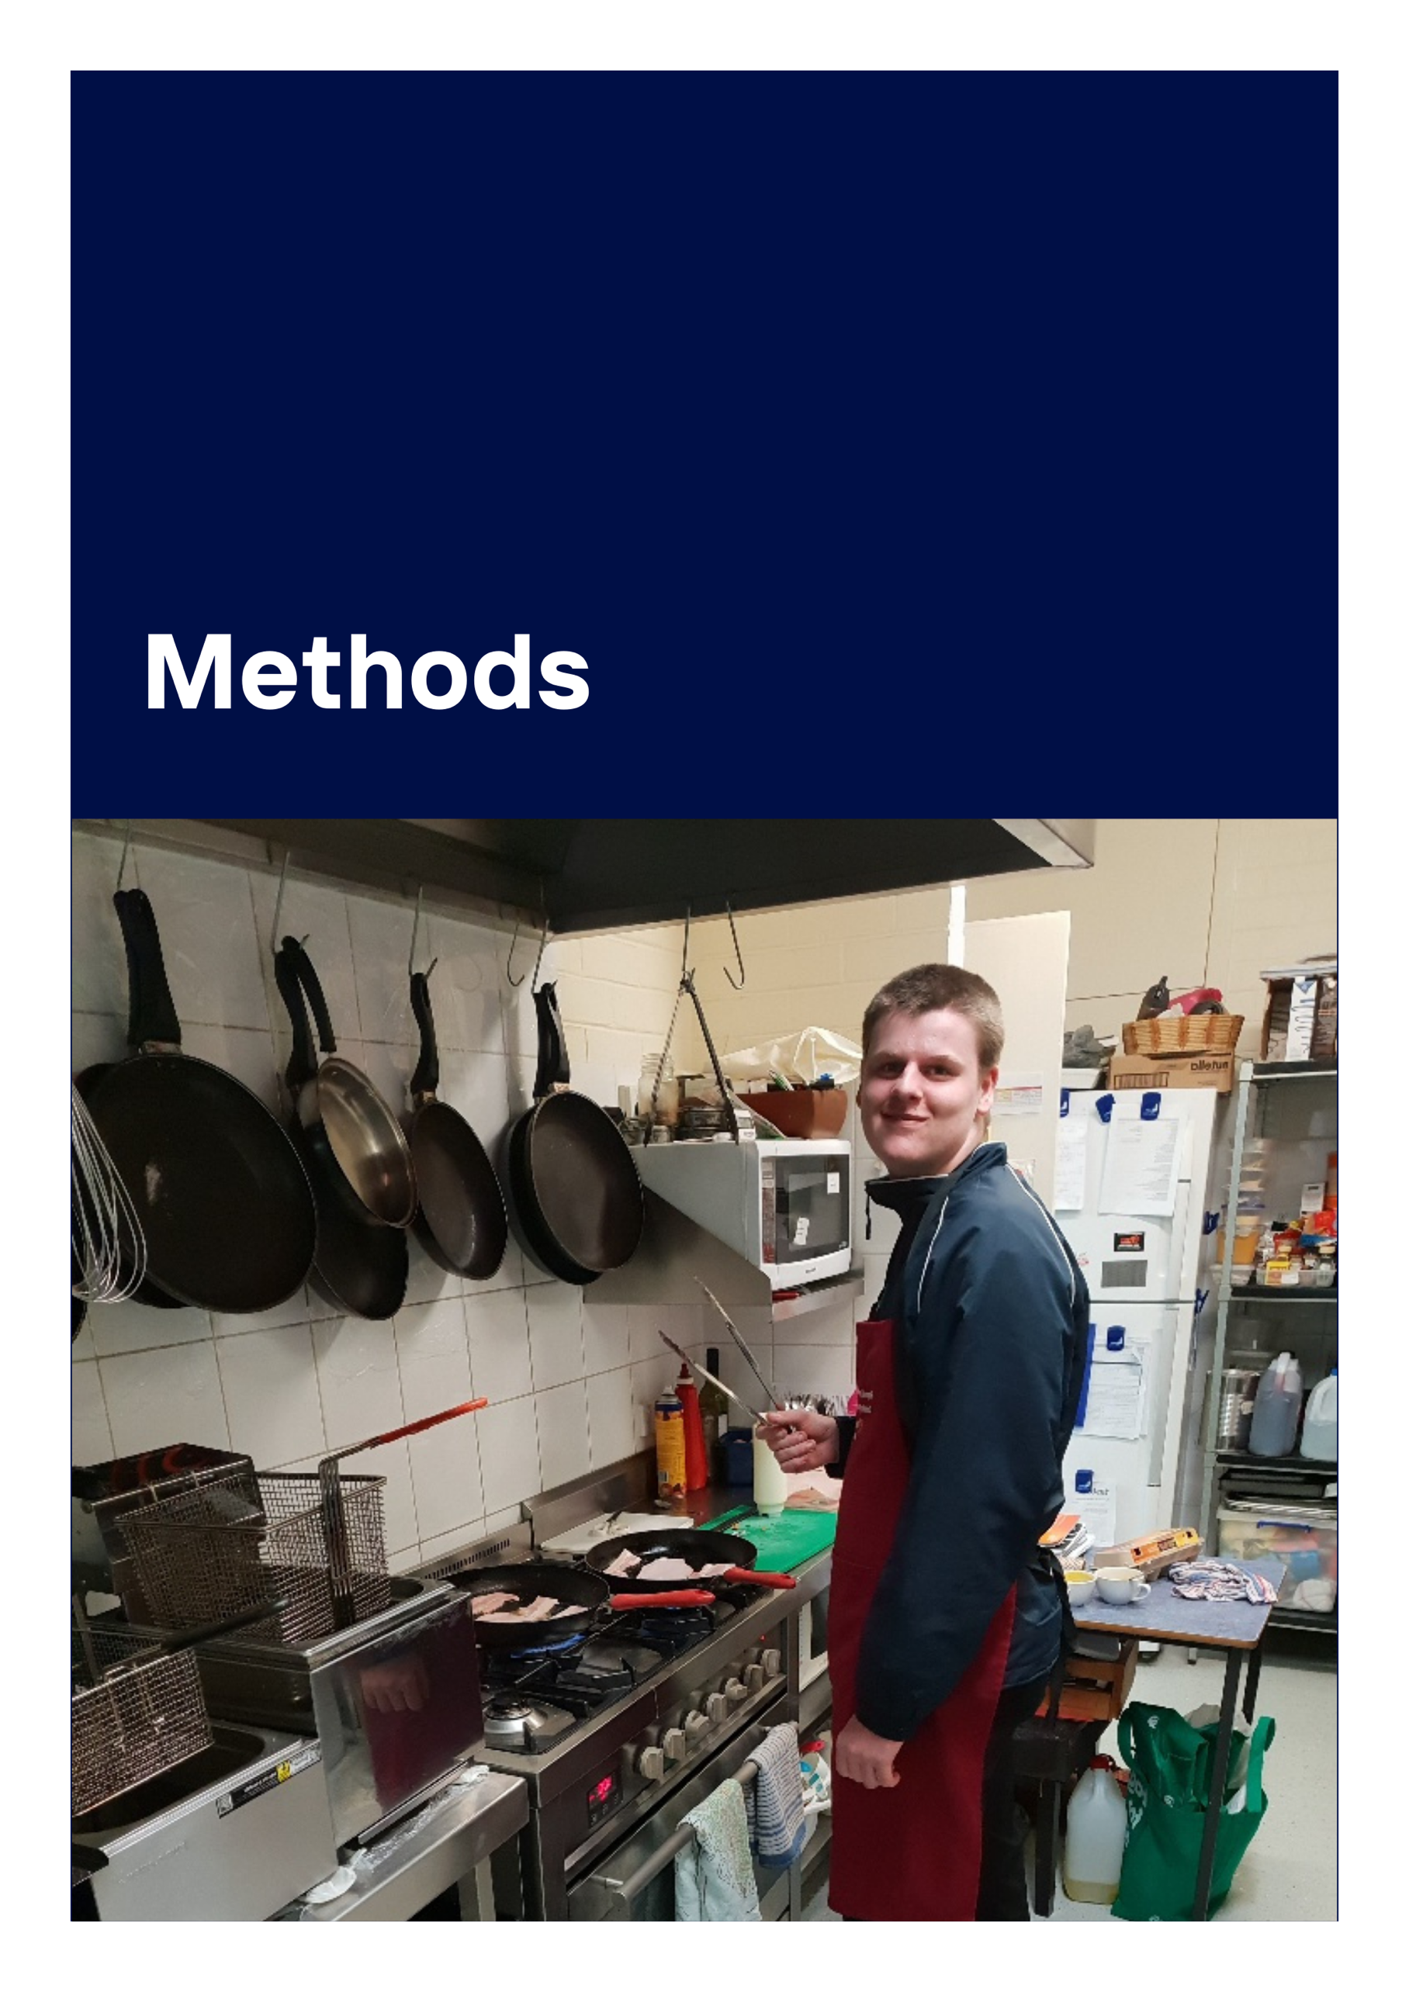

2. Methods

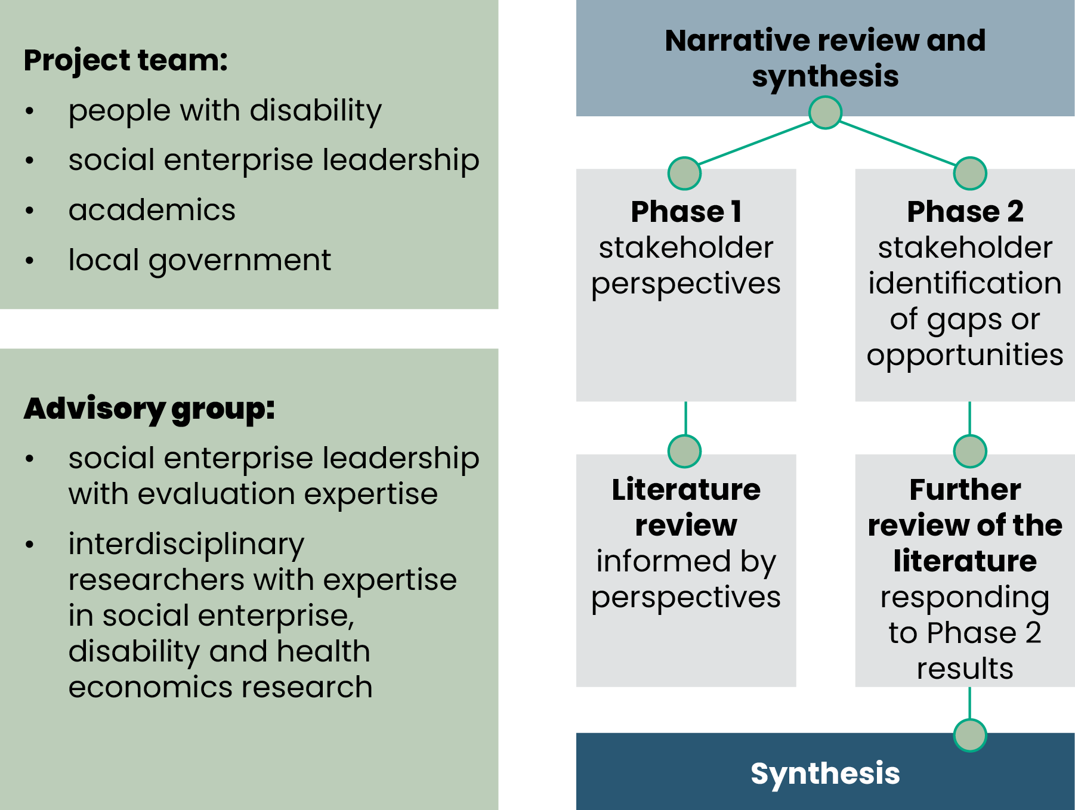
2.1. Study design

Our project received seed funding from Melbourne Disability Institute in 2023. In an emerging area of research, a narrative review and synthesis in two phases was conducted, responding to our broad research questions. The project team included people with lived experience of disability and social enterprise community partners employing people with disability. The project advisory group included leadership representation from an established social enterprise with experience in evaluation and interdisciplinary researchers with expert knowledge in the area of social enterprise, disability and health economics research.
The literature review synthesised a body of existing evidence on the evaluation of the public health impact of SEs for people who experience health inequities, with a specific focus on people with disability. Synthesised primary studies encompassed national and international peer reviewed literature. Synthesis further incorporated grey literature (to ensure that historically excluded voices from formalised research were included in the review). A narrative review allowed us to summarise and interpret primary sources which included a range of research designs and non-research evidence to identify factors shaping social enterprise’s approach to evaluation (Kitson et al., 2013; Mays et al., 2005; Popay et al., 2006; Sutton et al., 2019). Our synthesis was driven by two ‘evidence to practice’ key stakeholder consultation phases:
The first informed the review to ensure the design was comprehensive, relevant, and informed by multiple perspectives (social enterprise participants and staff – inclusive of people with disability, providers, funders, investors, and interdisciplinary researchers).
The second consultation phase, after identifying key themes in the initial literature review, and synthesising with phase one consultation findings, re-engaged phase one stakeholders to capture their views on gaps or opportunities arising from the findings, and what they thought may be needed to design, develop, and implement innovative evaluation approaches.

2.2. Ethics
The ethics application for this study was prepared with appropriate consideration of risk mitigation for participants with additional support needs. This included ensuring the approach and materials would enable the participation of people with disability engaged within the three social enterprise community partners. Approval was granted on 11th May 2023 by the University of Melbourne Human Ethics STEMM 2 Committee (ID: 2023-26106-40276-3). Participant documents are included in the appendices.

2.3. Key Stakeholder consultations
Recruitment for individual interviews was completed through convenience sampling of providers and/or funders of the three social enterprise project partners, funders of social enterprises known to members of the project team and interdisciplinary researcher stakeholders known to members of the project advisory committee. Recruitment to the three focus groups was facilitated by the sharing of project information documents within the social enterprise partner organisations. Ten social enterprise beneficiaries expressed interest in participating, and independent contact was established by the project research assistant via email - see Table 1. below for focus group participant characteristics. Nine participants agreed to individual interviews. Included in this group were some participants who were able to reflect experience from more than one perspective, including: provider, funder (including local government and philanthropic) and one interdisciplinary researcher. Written consent obtained from interview participants agreed to participate in two 30-minute semi-structured interviews. Consent (written or verbal) obtained from focus group participants prior to or immediately preceding the focus group, agreed to participation in two 60–90-minute focus groups. One in each phase of the project. Focus group participants were remunerated for their participation. All data has been managed as per the Australian Code for the Responsible Conduct of Research (National Health and Medical Research Council, Australian Research Council and Universities Australia, 2018).
Table 1: Focus group characteristics
Geographical location | Social Enterprise Mission | Number & Gender Identity | Age Distribution | Roles within the Social Enterprise
Outer Metropolitan location | Trades to respond to social issues. Provides access to affordable fresh food. Provides access to paid employment, training pathways & volunteer opportunities | 2 -Female  1 -Male | 18-25yrs=1  >25yrs=2 | 1 -employee  1- trainee  1 - volunteer
Metropolitan Melb | Neurodivergent-led social capacity building programs, co-designed with & for the Neurodivergent community. Provides paid employment for staff, delivering child participant programs | 3-Female  1 -Male | 18-25yrs=3  > 25yrs=1 | 4 -employee
Regional Vic | Seeks to empower communities to mentor, nurture and impart life-skills to people whose opportunities have been limited. 8-week youth focused work skills practical training and life skills program | 3 -Male | 18-25yrs=3 | 2 -employee  1 -trainee
*Participants identified experiencing life challenges associated with one or more of neurodivergence; psychosocial disability; physical disability; intellectual disability |  | Total:  5-Female + 5-Male  =10 | Total:  18-25yrs=7  > 25yrs=3 | Total:  Employee=7  Trainee=2  Volunteer=1

2.3.1. Phase one consultations
All phase 1 interviews and focus groups were completed between 23.05.2023 to 15.06.2023. All were audio recorded with participant’s permission, transcribed and de-identified.

2.3.1.1. Analysis
The first read-through of all data was guided by the research questions and discussion guides, deductively analysing the data. Following this initial read-through inductive analysis was undertaken to identify emerging themes and sub-themes.

2.3.1.2. Results
The narrative within focus groups and interviews about current approaches within social enterprises to evaluation and/or measurement of health impacts, reflected an overarching perception that this was either not currently being captured or took an ‘Ad hoc’ approach, with very varied tools and strategies being utilised. What was measured as impact was closely tied to the individual social enterprise mission, and information required for reporting to funders or for the purpose of seeking additional funding. Most of the discussion reflected the many challenges to creating a sustainable business (e.g., time and financial resources) leaving little opportunity to focus beyond ‘numbers’ data to report against core mission outcomes (e.g., the number of trainees completing a program). Though a variety of qualitative strategies were utilised to capture individual impacts, these ‘stories’ appeared to have limited opportunity for sharing. Leveraging from existing programs, knowledge and understanding was viewed as a pathway for developing ‘fit-for-purpose’ approaches to identifying, understanding, capturing, and sharing more widely the impact of social enterprise on public health outcomes, particularly for people with disability. The role of government, at all levels, was frequently reflected as required to achieve this.
Overall, conceptualizing the potential capacity to measure population health impact for people with disability fell under two key themes: Organisational characteristics and Individual/interpersonal characteristics and are summarised in Table 2.
Table 2: Phase 1 stakeholder consultation key themes and sub-themes
Organisational characteristics | Individual/interpersonal characteristics
A Fit-for-purpose business model and governance structure is required:  - To address the many challenges in creating a sustainable business, as multiple challenges leave little opportunity for identifying or understanding the full impact of engagement with the social enterprise for its beneficiaries*.  - whilst reflecting organisational values in the delivery of the vision & mission  - To nurture financial sustainability and enable leveraging from existing community programs, building internal knowledge, skills and understanding of how to capture broader impacts.  *When the term ‘beneficiaries’ is used it identifies people either employed by, trained by, or volunteer with the social enterprise. Our focus group participant population all identified as beneficiaries of the social enterprise core mission. | - Interpersonal relationships impact all stakeholders:  - Safe spaces were created by the development of trusting relationships between beneficiaries and providers.  - Role modelling was viewed by beneficiaries and providers as an important tool for supporting skill development, enhancing a collective sense of purpose, confidence in abilities and increasing independence.  - Developing social capital  - Feelings of being:  - valued  - respected  - empowered  - belonging  - able to have a ‘voice’!  - Improved health & wellbeing:  - Mental health  - Physical health  Overall quality of life
Organisational barriers to evaluation include:  - Time  - Financial resources & sustainability  - Evaluation or impact measurement skills, knowledge & experience  - Currently taking a very ‘Ad hoc’ approach to identifying broader impact monitoring, measuring, or reporting (including health and wellbeing impacts).  Undervaluing the ‘ripple effect’ as a multiplier of measured outcomes on broader impacts | Employment or employment pathways goals are:  - meaningful  - valued  - ‘Next step’ outside SE  - Developing work/life skills goals:  - need individualised approaches.  Support peer and social connection
Organisations are on a journey towards achieving their mission outcomes, building capacity within individuals, the business and community, including mainstream services. They are looking at the role of government at all levels in supporting social enterprises to become a sustainable business with the internal skills to understand and capture their broad impact. | Disability disclosure needs a safe and supportive environment

For beneficiaries, access to this environment has developed knowledge and skills that enabled forward planning. At the same time, strong interpersonal relationships in multiple directions between stakeholders engendered a sense of belonging and empowering individuals to find their ‘voice’. Amongst this was the high value placed on beneficiaries’ and provider stakeholders’ capacity to act as ‘role models’. Development of this social capital was viewed as building the capacity of the social enterprise itself, its target beneficiaries, all associated stakeholders, and the wider community. This was frequently referred to as ‘the ripple effect’.

2.3.2. Phase two consultations
All phase 2 interviews and focus groups were completed between 25.07.2023 to 04.10.2023. All were audio recorded with participant’s permission, transcribed and de-identified.

2.3.2.1. Analysis
This analysis was guided by the synthesis of results arising from phase one consultations and literature review, to identify the gaps and opportunities discussed.

2.3.2.2. Results
The current gaps and potential opportunities for measuring the population health impact for people with disability are summarised in Table 3. One of the most frequently reported gaps in capacity was time:
… time and a structured way for us to look and really analyse our social enterprise and not just as a business, but as a social enterprise … (Interview - P3)
Correspondingly, the most optimistic opportunity was identified quite late in the project with the launch of ‘Seedkit’! An online tool designed and maintained by the Centre for Social Impact at Swinburne University and Melbourne Social Equity Institute, to assist social enterprises with measuring, tracking, and communicating their impacts. It offers social enterprises a fairly simple way to either choose pre-developed indicators or develop their own, specific to their business type and goals. The data reports it generates enable individual social enterprises to report on impacts, but data can also be aggregated for anonymised reporting to policymakers and funders for sector impact. The extent of adoption and ways the sector utilise the tool, will no doubt inform tool refinements. Of particular interest will be whether feedback indicates the tool has proven to be time efficient.
Table 3: Phase 2 stakeholder consultation identified gaps and opportunities
Gaps
- Definition – no consistent definition of what is identified as a social enterprise, presenting challenges when seeking philanthropic or government funding support during establishment, or when seeking support to grow the business.
- Social enterprise beneficiaries need to be at the centre of activities to identify and assess the type and quality of any impact attributed to their engagement with the social enterprise. This was particularly perceived by beneficiaries as a way of ‘giving back’.
- Leveraging opportunities: several interview participants highlighted where pre-existing work, particularly at local government level, could be utilised to progress the development of social enterprise specific, fit-for-purpose tools & resources, for communicating their impact.
- Capacity building through education was viewed as required for:
- Individuals e.g., to develop life skills and connect to opportunities beyond the social enterprise.
- The social enterprise sector.
- The community, particularly within:
  - Local government e.g., in procurement policy and development of evaluation skills.
  - Local employers e.g., understand the opportunity to recruit from a skilled social enterprise workforce.
  - Local businesses e.g., understand the broad benefits of procurement from a social enterprise.
  - Local education providers e.g., engagement with social enterprise for students at risk of difficulty when seeking employment.
  - Building community wide understanding of the benefits of procurement from a social enterprise.
- Absence of an established local social enterprise network.
- Locating appropriate funding opportunities is made more challenging by the lack of social enterprise sector representation within decision making processes.
Opportunities
- Introduction of Seedkit. Questions remain:
- What data will be collected to build into a body of evidence to respond to the question around public health impact for people with disability?
- At the individual social enterprise level, how will the data captured (individual and sector) be utilised to create positive impact for all stakeholders?
- Explore what needs to happen to create a common definition e.g.:
- What are the current processes to register as a social enterprise?
- How is inclusive language being utilised?
- Further research is required to investigate the role of social enterprise in delivery of public health outcomes for people with disability and the economic impact of those outcomes.
- With the local government requirement for social objective outcomes, is this an opportunity for local government to partner with local social enterprises and draw from existing programs, knowledge, and capabilities to enhance the sector’s capacity to identify, capture and communicate broader outcomes and impacts, whilst also building knowledge and understanding of the benefits social enterprises can deliver for local government?
Some of the benefits for local government identified by participants included:
- Their potential to impact social determinants of health.
- Understand the benefit of re-orienting local government procurement policy towards local providers, including social enterprise providers.
- Advocating together to remove barriers to achieving their intended impacts e.g.:
  - Excessive cost of registering to be a social trader.
  - Supporting business growth to scale for greater impact.
  - Recognising that for potential local social enterprise beneficiaries, transport is often a barrier to participation.
- Many participants saw the opportunity for further research to examine the role of government -Local, State, Federal e.g.:
- Understanding the impact of the Federal government White Paper (2023) and opening up of the social enterprise investment fund.
- What is the impact arising from the Victorian Social Enterprise Strategy 2021–2025 move from dedicated State government department responsibility to dispersed responsibility?
At both State and local government levels, will this impact access to funding?
- Several participants suggested there was an opportunity for local government to take a lead role establishing a local social enterprise network.

2.4. Narrative Review
The purpose of the review was to provide an overview of whether and how current approaches to evaluation enable individual social enterprises and/or the sector to capture public health impacts. This review was specifically focused on the population health outcomes for people with disability.

2.4.1. Search strategy
Informed by phase one stakeholder consultations and a preliminary scoping search, inclusion and exclusion criteria were confirmed and a search strategy developed. See Table 4. for inclusion and exclusion criteria.
Table 4: Inclusion and exclusion criteria
Inclusion Criteria | Exclusion Criteria
- English language  - Published from 2013 – 2023.  - The population of interest was focused on people with disability as representative of people who experience health inequities.  - The study included examination or discussion or evaluation of health &/or wellbeing outcomes, or impact on social determinants of health or health inequities.  - The study reported outcomes from the perspective of any social enterprise stakeholder including:  - Paid or volunteer participants with disability  - Paid staff – program leaders/providers  - Philanthropic or other funders/investors | - Not published in or translated into English.  - COVID impacts
A systematic search was conducted on 27 June 2023 across three databases: Ovid Medline, SocINDEX, and CINHAL. Groups of search terms relating to social enterprise, disability and evaluation were developed, Boolean operators were applied and filtered for currency by date range 2013 to 27.06.2023 (see Table 5). They were combined into searches run in the three databases. Grey literature was identified through website and citation searching in: Google Scholar, APO Disability Research Collection and Google: site.gov.au. Additional resources were provided by research project partners and project advisory committee members. Only English language literature was included.
Table 5: Ovid Medline, SocINDEX and CINHAL search terms
Group 1: Search terms related social enterprises | Group 2: Search terms related to disability | Group 3: Search terms related to evaluation or health or wellbeing
(social adj2 (enterprise* or business* or entrepreneur*)).mp. | (disabil* or disabled).mp. | (assess* or evaluat* or measure* or analysis or analyse or scale* or survey or questionnaire* or outcome* or impact* or benefit* or determinant* or health or wellbeing).mp.

2.5. Results of Narrative Review

2.5.1. Selection of literature
Articles were considered for inclusion through title and abstract screening, followed by full-text screening. Grey literature was considered for inclusion where it added to the currency of evidence related to how health outcomes can be identified, measured, or evaluated, and reported by social enterprises. Following completion of phase two stakeholder consultations, the same search strategy was applied, filtered by date range 27.06.2023 to 19.11.2023, to identify any additional reports for inclusion.
The three database searches identified 60 records and removed four duplicates and one other paper not available in English. A total of 55 records were screened and 39 excluded based on title and abstract review. Full versions of 16 articles were retrieved and screened for eligibility. An additional 72 records were identified through project partners, website and citation searching. Screening excluded 64 records, with four articles and four reports included. A total of 20 articles and 4 reports were included. (See Fig.1. for a flow diagram of the study selection process). Table 6 displays the summary details of the records included.

Figure 1: Flow diagram of literature selection process

2.5.2. Characteristics of included literature
Of the 24 records included in the review, four studies were undertaken in Canada, seven in each of Australia and the United Kingdom, four in Italy, and one each in Germany, South Africa, Korea and Hong Kong. Two of the studies were reporting from multiple sites around the world.
No. | Author, Year, Country & Title | Purpose | Study methods | Study population | Outcomes investigated | Study findings
1 | Vilotti et al. (2018) Canada  A serial mediation model of workplace social support on work productivity: the role of self-stigma and job tenure self-efficacy in people with severe mental disorders | Contribute to understanding why people with severe mental illness face the greatest stigma and barriers to employment opportunities. | Quantitative descriptive  Questionnaires validated for use with target population. Process modelling is used to test serial mediation. | 170 people with a severe mental disorder employed in a Social Enterprise. | The relationship between workplace social support and work productivity, taking account of the mediating role of self-stigma and job tenure self-efficacy. | Social support yields better perceptions of work productivity through lower levels of internalized stigma and higher confidence in facing job-related problems.
2 | Kordsmeyer et al. (2022) Germany  Balancing social and economic factors – explorative qualitative analysis of working conditions of supervisors in German social firms | To address the limited evidence on the work and health situation of supervisors in social firms and develop recommendations for action on workplace health promotion. | Qualitative | 16 supervisors of social firms providing employment opportunities for people with different types of disabilities. | Explored job demands and resources of supervisors in social firms. | Supervisors reported job rewards and demands associated with the specific SE & the broader sector. Meaningful work with a variety of tasks and a good working atmosphere were influenced by individuals’ characteristics such as patience and empathy. These positives were counterbalanced by challenges associated with high work intensity and unpredictability leading to overtime. Further challenges were felt by the conflict experienced between the social and economic goals of the business.
3 | Trafford et al. (2021) South Africa  More than just assistive devices: How a South African social enterprise supports and environment of inclusion | To address the gap in evidence that describes contextually relevant approaches to meeting the assistive technology needs of disabled people in African countries. | Case study | The Shonaquip Social Enterprise (SSE) – people with disability. | Identifying principles to consider when trying to provide for the needs of people with disabilities, particularly in low-resource settings. | A holistic approach within the business model can support a wider perspective of inclusion and participation. Challenging the broader environment to promote community-led inclusion is as essential as providing individuals with assistive technology/devices to facilitate their inclusion and participation.
4 | Kordsmeyer et al. (2020) Canada, Australia, UK, Italy  Working conditions in social firms and health promotion interventions in relation to employees’ health and work-related outcomes - A scoping review | To provide an overview of the current state of research on working conditions, coping strategies, work- and health-related outcomes, and health promotion interventions in social firms to derive recommendations for action. | Scoping review | 22 studies with a focus on psychosocial disability.  3 with a focus on developmental disabilities. |  | Employees often have access to several work accommodations.  A mix of environmental & personal resources influences work-related outcomes.  Further research is needed to identify the work and health situation of employees and for the development of health promotion interventions.
5 | Cho et al. (2019) Korea  Using the photovoice method to understand experiences of people with physical disabilities working in social enterprises | To examine the experiences of disabled SE employees | Qualitative - Photovoice | 5 employees with physical disabilities | Explored the life experiences of people with disabilities working in social enterprises, using the photovoice method. | SE might provide people with disabilities supportive workplace environments, which may improve their quality of work life.
6 | Vilotti et al. (2017) Australia, Canada, Italy  Work accommodations and natural supports for employees with severe mental illness in social businesses: An international comparison | To identify the types of work accommodations and natural supports that are useful for people with severe mental illness working in social enterprises. | Quantitative survey | SE employees with self-reported psychiatric disabilities. | An exploratory, descriptive, and cross-sectional investigation to study the nature of work accommodations and natural supports available in social businesses. | Regardless of the country, SEs provided many work accommodations and natural supports, such as schedule flexibility and support, and were linked to longer job tenure for people with severe mental illness.
7 | Chui et al. (2023) Hong Kong  The role of social enterprises in facilitating labour market integration for people with disabilities: A convenient deflection from policy mainstreaming? | To add to the research on social enterprises in the context of disability in relation to labour market integration. | Qualitative | 21 WISE employees | This study examines whether and how work integration social enterprises (WISEs) promote inclusion for people with disabilities and explores the transition into open employment. | Despite stated intentions of public policy, the ability of WISEs to enable the transition of people with disabilities to the open labour market was limited.
8 | McKinnon et al. (2022) Australia  Social enterprises and community wellbeing in regional Australia | To map the ways in which social enterprises in regional Australian cities produce wellbeing for their employees. | Qualitative | 19 staff with disability in regional social enterprises.  10 community informants from 2 regional cities in which the SEs were located | How are social enterprises understood to be contributing to regional communities. | Situates social enterprises as key actors in a community economy that contributes to wider community wellbeing as distinct from individual wellbeing.
9 | Larratta, R. (2016) Italy  An interface between mental health systems and community: Italian social cooperatives | To identify the major factors that make this business model successful. | Secondary analysis of Qualitative data collected for a project on ‘Disability and Employment’, and a case study.  A Social Cooperative case study conducted interviews supplemented with observations | People with ID or mental health challenges employed within social cooperatives in Turin Italy. | Explore factors that account for the sustainability and growth of social cooperatives. | Cooperatives have been able to address stigma.  By building assets, experiences, and expertise, cooperatives, public administration, and for-profit enterprises demonstrate local services can be delivered more efficiently, building community through 3 key factors: 1) effective regulation 2) a support system of infrastructures 3) a totally democratic operational governance
10 | Lysaght et al. (2022) Canada  Best practices in evaluating work integration social enterprises for persons with intellectual disabilities: A scoping review | To identify best practices for evaluating emerging work integration social enterprises (WISEs). | Scoping Review | WISEs with a focus on persons with cognitive disabilities. | Evaluation approaches to assessing outcomes of WISEs for persons with intellectual disabilities, including how the business develops outcomes, and the challenges or strengths of approaches. | No discussion of ‘best practice’ in evaluation identified in the literature.  Many inherent challenges exist in evaluation of social enterprises.  Promoting an evaluation culture is critical to the sector.
11 | Roy et al. (2014) UK  The potential of social enterprise to enhance health and well-being: A model and systematic review | To understand the potential of social enterprises as a model for enhancing health and well-being. | Systematic review | Social enterprises in included studies were located in the US, Hong Kong, Canada, and Australia. | The impact of social enterprise activity on health outcomes and their social determinants. | Limited evidence of positive impact on overall health and well-being.  Need for research to evidence causal mechanisms of social enterprise activity, and wider civil society actors, upon a range of intermediate and long-term public health outcomes.
12 | Suchowerska et al. (2020) Australia  An organizational approach to understanding how social enterprises address health inequities: A scoping review | Map the key concepts and evidence examining how interlinked organisational features affect the general social impact of social enterprises, and health equity and health equity outcomes. | Scoping review | Studies that looked at the impact of social enterprise on health equity and health equity outcomes. | Examine the intersection between social enterprise, social determinants of health and health equity outcomes. | Draws a conceptual distinction between transformational and transactional organisational features. Most empirical research does not examine the causal mechanisms embedded in social enterprise organisations working to alleviate health inequities and improve health equity outcomes.
13 | Mason et al. (2015) Australia  Social innovation for the promotion of health equity | To systematically review the available evidence of the relationship between social innovation and its promotion of health equity. | Systematic review of scholarly & grey literature. | Examining four types of social innovation—Social movements; Service-related social innovations; Social enterprise; Digital social innovations. | Available evidence of the relationship between social innovation and its promotion of health equity. | Relatively limited evaluative evidence of the impacts of social innovations.  Immaturity in evaluation and impact measurement and the complexities of measuring change.  Identifies gaps for future research.
14 | Caló et al. (2019) UK  Exploring the contribution of social enterprise to health and social care: A realist evaluation | To assess the impact of a social enterprise-led activity on beneficiaries in comparison to a public sector organisation. | Qualitative – realist evaluation | SE beneficiaries, service providers and external stakeholders. | What outcomes were produced by the social enterprise and the comparator organisation, how these were produced and the significance of context. | Policy implication: social enterprises under certain circumstances can be as good as public sector organisations providing similar services, when sufficient, sustained funding is available to deliver bespoke services to the communities they serve.
15 | Caló et al. (2021) UK  Evidencing the contribution of social enterprise to health and social care: approaches and considerations | To support the establishment of a robust evidence, base for the use of social enterprise as a policy instrument. | Mixed methods | Approaches common in the evaluation of complex public health interventions:  - systematic reviews  - realist evaluation  - quasi-experimental investigation | Assesses the potential of three methodological approaches. | Findings of this research raise doubts about the utility of adopting only one tool. Integrated approaches are likely more appropriate. All approaches are resource intensive and require specific skills and specific funding for data collection.
16 | Macaulay et al. (2018) UK/Scotland  Conceptualizing the health and well-being impacts of social enterprise: A UK-based study | To add empirical work focusing upon how, and to what extent, social enterprise-led activity may impact upon health and well-being. | Qualitative analysis of ‘assured’/’audited’ Social Accounting and Audit (SAA), and Social Return on Investment (SROI) evaluative reports, using a ‘process coding’ method. | Social enterprises in Scotland. | How social enterprises portray their impact, and how such impacts may be considered in health and well-being terms. | Presents an ‘empirically informed’ conceptual model of the health and well-being impacts of social enterprise led activity.  Identifies social enterprises directly and indirectly act as potentially valuable ‘non-obvious’ public health actors, with implications for public health policy and practice.
17 | Roy et al., (2017) UK/Canada  Action on the social determinants of health through social enterprise | Explore the notion that social enterprise and social entrepreneurship could potentially have an influence on the social determinants of health. | Opinion piece | Target beneficiaries of WISEs | Identifies WISEs as a poorly understood, highly complex form of intervention to address the social determinants of health. | Discussion highlights the need for research to unpack and understand the causal pathways of how social determinants of health can be both identified, measured, and reported to explore the impact of social enterprises on health and health equity.
18 | Whitelaw et al., (2023) UK  Fostering resilience in young people with intellectual disabilities using a ‘settings’ approach | To reflect on the theoretical core conceptual nature of resilience and ‘settings’-based mechanism for its promotion and explore their inter-relatedness. | Qualitative (case-study) | Internal (trainees with ID & staff) & external stakeholders of case. | Examine how organisations might nurture and enact a culture that fosters resilience. | Features associated with fostering resilience – ‘whole organisation’ (settings) approach based on high levels of participation and choice; the negotiation of a constructive dynamic tension between ‘support’ and ‘exposure’; embedding these actions in embodies actions and day-to-day organisation activities.
19 | Joyce et al., (2022) Australia  The health and well-being impact of a work integration social enterprise from a systems perspective | To understand the way in which the contextual elements within the organisational structures and strategies used by Work Integration Social Enterprises (WISEs) influence the mechanisms by which health outcomes are produced. | Realist evaluation of 4 Qualitative case studies | Internal & external stakeholders of social enterprise cases with young people experiencing mental health challenges their beneficiaries. | Pathways by which social enterprise influence health and well-being within the context of WISEs. | WISEs can impact the social determinants of health through facilitating employment, providing increased income, a sense of purpose and structure, and opportunities for social connection and cohesion.
20 | Klarin et al., (2023) Australia  An Integrative Literature Review of Social Entrepreneurship Research: Mapping the Literature and Future Research Directions | To respond to the call to integrate the disparate Social Enterprise (SE) research. | A combined scientometric review with a systematic literature review. | Social enterprises | To provide a holistic overview and understanding of the literature and current trends in SE research. | Synthesised SE research into five SE themes:  - nature of  - policy implications & employment  - communities & health  - personality traits  - education  and outlines future research directions.
21 | Australian Government (2023)  Working Future  The Australian Government’s White Paper on Jobs and Opportunities | A roadmap to position the Australian labour market for the future. | Government White Paper | Policy area 9 – Partnering with communities – identifies people with disability as one of the groups facing disadvantage in gaining employment. | Objective 5: Overcoming barriers to employment and broadening opportunity | Government will partner with and invest in the social enterprise sector through the Social Enterprise Development Initiative (SEDI) to build sector capacity, with the goal of improving employment outcomes for those experiencing entrenched disadvantage such as people with disability.
22 | European Commission, OECD (2015)  Policy Brief on Social Impact Measurement for Social Enterprises  Policies for Social Entrepreneurship | To present the issues and ongoing debates surrounding Social Impact measurement. | Policy brief | OECD Social Enterprises | Examples of measurement methods and the challenges faced by social enterprises, including policy issues. | Social enterprises have limited human and financial resources to conduct social impact measurement.
23 | VicHealth (2015)  Australia  Promoting equity through social innovation | To provide policy makers and practitioners in Victoria and across Australia with practical, evidence-based guidance on using social innovation to promote health equity. | Report | Populations experiencing health inequities including people with disability. | Social innovations that evidence successful impact or potential to address health inequities. | Identifies social enterprise as one social innovation with the potential to address health inequities, identifying the challenges faced when they seek to address health inequities.
24 | Wilson et al., (2021)  Australia  Summary Report. Mapping the employment support interventions for people with work restrictions in Australia | To undertake a cross-sector scan of the employment supports landscape. | Report | Employers of individuals with an injury, ill health, or disability. | Definition of employment supports. Comparison of supports delivery across systems. | Social enterprise employment can provide wrap-around support and spaces that blend training and work opportunity in such a way that is uniquely flexible and suited to diverse participants. Identifies gaps and opportunities across systems and makes recommendations for future directions.

2.5.3. Quality Assessment
As there were various study methods utilised in the literature included in the review, quality assessment was undertaken using the Mixed Methods Appraisal Tool (MMAT) version 2018 (HONG et al., 2018) and the JBI critical appraisal checklist for systematic/scoping reviews (Aromataris et al., 2015). Five studies were reporting systematic or scoping reviews, nine took a qualitative research approach, two articles reported quantitative descriptive studies, and Caló et al. (2021) used mixed methods, applying three approaches to evaluation for the purpose of comparison. Finally, seven included references were assessed using the AACODS Checklist for grey literature (Tyndal, 2010). No literature was excluded based on their quality assessment. Results of the quality assessments are presented in Appendix 1.

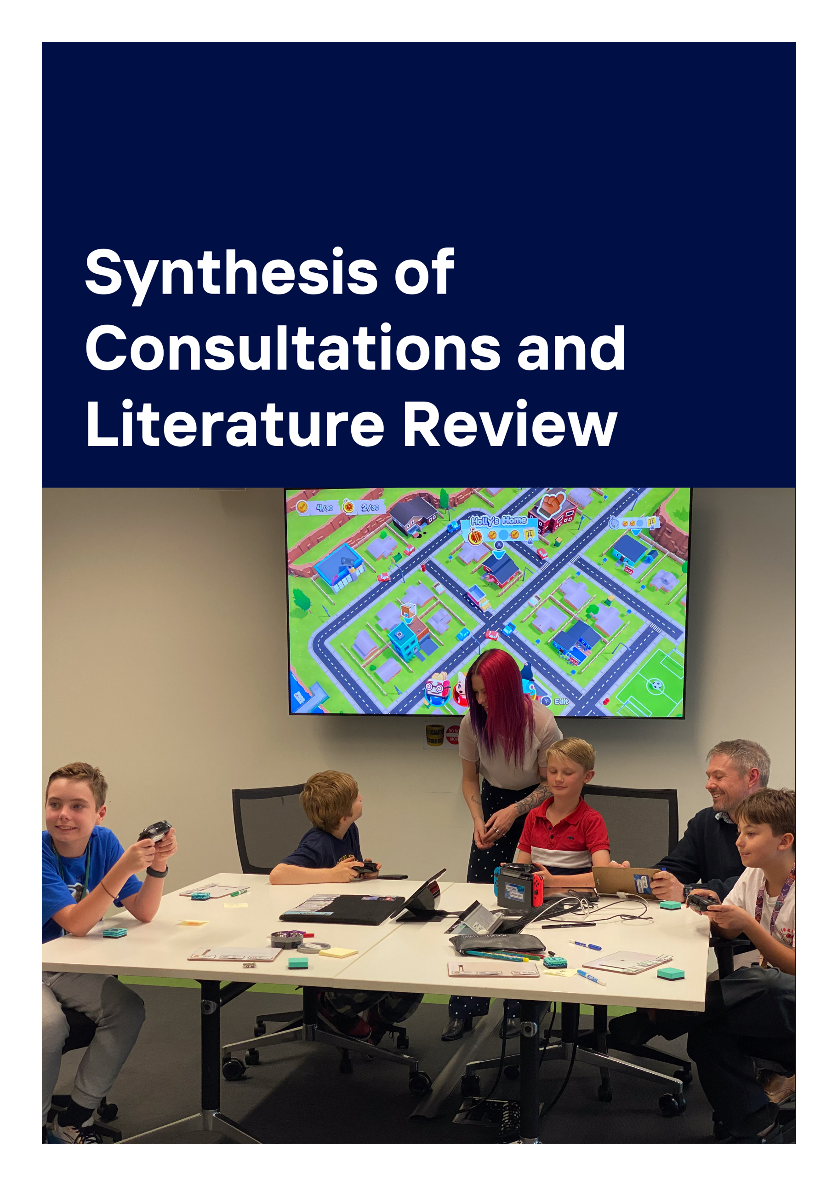

3. Synthesis of Stakeholder Consultations and Literature Review Results
Within stakeholder consultations and the reviewed literature, the overarching narrative conceptualised the potential for social enterprises to positively impact the social determinants of health. However, when considering how this may be captured and reported, focus group and interview participants identified a very ‘ad hoc’ approach to evaluation of health outcomes - “We do it ad hoc and I wish we had a way to do that a lot better.” (Interview 1 - P3), with Roy et al., (2014) identifying intermediate and long-term public health outcomes as currently under-investigated. Our literature review hasn’t identified any studies that specifically responded to our first question, identifying approaches to evaluation that capture the public health impact of social enterprises. However, Macaulay et al. (2018) do present a conceptual model of how social enterprise led activity can impact health and well-being. Several studies described organisational characteristics that have the potential to work together to impact individual health and wellbeing by their action on the social determinants of health (Joyce et al., 2022; Roy et al., 2017; Suchowerska et al., 2020; Villotti et al., 2018).
Social enterprises were viewed as holding both organisational and individual stakeholder characteristics with the potential to positively impact health outcomes for people with disability (Suchowerska et al., 2020). These were organisational characteristics such as the provision of safe and supportive working environments (e.g., individualised support, flexible working arrangements), where beneficiaries and providers alike felt mutually valued and respected:
… here at [SE], they accepted all of that. They made me feel like I was wanted, I was needed, I was – it was just fantastic the way they treated people. (Focus Group - P1.3)
… after I felt like I had engaged with the team, I experienced the first sense of belonging. I discovered some sense of purpose. I, through my work skills, understood that I am quite unique, that I’ve got something to offer, and I was respected in that process. These are the common things we hear [from trainees]. (Interview - P2)
Across the reviewed literature and stakeholder consultations five key themes emerged, describing how these organisational and individual stakeholder-level social enterprise characteristics have the potential to influence public health outcomes:
When social enterprise thrives, they really echo, I think, the promise of better health and brighter futures. And I think for governments, investing in them is not just funding a cause or a great idea, it's nurturing the very roots of societal wellbeing and planting seeds for a prosperous tomorrow. (Interview - P2)

Reporting under the five key themes summarised below, we indicate potential metrics for collection or approaches to be taken when considering the development of easy-to-use, widely shared tools and metrics.
Key Themes:
- Social enterprise context
  - Characteristics of the Social Enterprise
  - Characteristics of the community within which a Social enterprise is situated
  - Characteristics of the broader political and economic environment in which the Social Enterprise operates
- Measuring and communicating social outcomes/impacts
- Challenges in capturing the public health impact(s) of social enterprises
- Leveraging
- Capacity building

3.1. Social enterprise Context

3.1.1. Characteristics of the Social Enterprise
Social enterprises can play a significant role in integrating people with disability into the labour market, by creating supportive environments that address the physical, social and stigma barriers they experience (Villotti et al., 2018). The governance model of a social enterprise is crucial to ensuring an inclusive environment aligns the business model with the organisation’s mission. A robust governance model is required to ensure that the social enterprise remains focused on its mission.
Effective governance enables an organisation to deliver on its social objectives while maintaining financial sustainability. Laratta (2016) describes how regional Italian social cooperatives built on experience and expertise, to develop a democratic governance model, giving voice to their diverse stakeholders. This enables organisational structures that afford better stakeholder participation in resource allocation, strategic planning, and accountability (Kordsmeyer et al., 2020; Kordsmeyer et al., 2022; Laratta, 2016; Mason et al., 2015; Suchowerska et al., 2020; VicHealth, 2015; Vilotti et al., 2017, 2018; Whitelaw et al., 2023). This leads to social enterprises achieving financial sustainability, which allows the continuation of support provision to people with disabilities over the long term, contributing to their overall health and wellbeing (Australian Government, 2023; Klarin & Suseno, 2023; Macaulay et al., 2018; Trafford et al., 2021; Wilson et al., 2021).
However, our stakeholder consultations identified diverse social enterprise missions. A diversity of mission meant diverse organisational structures. Typically, this included a mixture of employees, volunteers and trainees, each with an identified role and responsibilities.
…from the volunteers that we have that come in on our program and just literally help, our staff, our mentors, our trainers, our life skills facilitators, our board. (Interview – P2)
Some employees and volunteers were the target beneficiaries identified in the social enterprise mission statement, while others indirectly benefit from their engagement with the social enterprise. But this did not guarantee the development of a robust social enterprise governance model:
Yeah, I mean I'm wondering … whether the model, the governance model, isn’t actually working … is there one, I don’t know, or could there be one that would enable a social enterprise to survive and thrive. (Interview – P6.2)
In their qualitative study with supervisors in social firms Kordsmeyer et al. (2022), identify the challenges arising from conflict between the social and economic goals articulated by the business. Strength and clarity of the mission statement, partnered with the right skill set at the time of establishment, influences the social enterprise’s capacity to develop an effective governance model. The skill set available is reflective of the people involved. This can be entrepreneurs, a driving force passionate about social change (Klarin & Suseno, 2023; Lysaght et al., 2022), or investors, including philanthropists, essential to establishment but most interested in the proposed social impact of an enterprise (Macaulay et al., 2018). But integral to the development and delivery of a governance model that aligns with the mission statement are the volunteer board members. They bring diverse professional backgrounds and ideally a compliment of skills.
We have full-time jobs. … But out of our volunteer time, we sit on the board … wonderful little social enterprise that many people have now invested into … – my background has also been in social work, … I've worked a lot at a community level and a mental health counselling level. (Interview – P2)
Complimenting these passionate supporters of a social enterprise are key stakeholder employees and volunteers, either of whom may also be the beneficiaries of the enterprise’s social mission. The role and impact of interpersonal relationships between these stakeholders, for individuals, the business and the wider community cannot be underestimated.
Social enterprises create inclusive environments where providers and beneficiaries can interact and build relationships, fostering a sense of belonging and community. These relationships are based on personal dignity and equality, empowering beneficiaries by focusing on their strengths rather than their disabilities. Emphasis is placed on the importance of enabling connectedness and the development of social capital to enhance all individual’s health and well-being (Laratta, 2016; McKinnon et al., 2022; Roy et al., 2014). In their scoping review Suchowerska et al. (2020) found the literature highlighted the importance of positive interpersonal relationships, team morale, trusting relationships, empathy and respect among employees as enabling factors for social enterprises to improve personal and community wellbeing.
The relational aspects of the work environment often play a more significant role in improving well-being (Suchowerska et al., 2020). Positive role models within the enterprise, whether they be providers or beneficiaries, can inspire personal growth and development among people with disabilities, enhancing their self-esteem and mental health (Caló et al., 2019; Joyce et al., 2022; Kordsmeyer et al., 2020; Mason et al., 2015; Roy et al., 2014, 2017; Suchowerska et al., 2020).
… it’s so rewarding. It just – you know, you don’t realise how much you are contributing to helping other people until you see those statistics sometimes. (Focus group – P1.3)
This helps create strong ties and feelings of connectedness between beneficiaries, organizational staff, and community stakeholders (Caló et al., 2019). Further, these role models can inspire broader community engagement and support, fostering a more inclusive and supportive environment for people with disabilities and community members (Klarin & Suseno, 2023). Stakeholder consultations similarly reflected on the broader impact of interpersonal relationships and role models, often referring to these as ‘ripple effects.’
I think ripple effects are really important things. They show that the people that engage in the social enterprise … the individuals themselves … they grow in confidence and then go on to get another job, they have better relationships at home. There are all those ripple effects that we don't normally bring into our evaluations but they're really important to show if you really want to show the full impact. (Interview – P6.2)
To achieve broad impacts, a social enterprise needs a business model that supports the challenge of managing economic performance whilst delivering on its mission (Kordsmeyer et al., 2022). This dual focus assists the enterprise to attract diverse funding sources and support, grow the business through financial sustainability, and ensure beneficiaries experience the intended impacts (Australian Government, 2023; Kordsmeyer et al., 2020). By reinvesting their profits into their social missions, social enterprises ensure that their health benefits are sustainable and can continue to benefit a community over the long term (VicHealth, 2015). McKinnon et al. (2022) identify the significant role social enterprises play in regional Australia. By providing supportive work environments, engaging with the community, and demonstrating alternative business models, community wellbeing is enhanced through prioritisation of the social and environmental missions of the social enterprises.
Overall social enterprises create supportive and inclusive work environments.
And then belong — I got a sense of belonging. I came here and everybody when I walked in the very first day. I walked in, "Good morning, hello, how are you?” And they all smiled at me and to each other and everybody. It's a place where I think everybody is put on the same level. There's no discrimination. (Focus group – P1.1)
It makes you feel like you have purpose, and you feel like you're helping people, that's what I get out of it all. (Focus group – P1.3)
… everyone that works here has that expectation, we’re here to help people, to be supportive of people …, everyone is just really supportive of each other, and it is just a really positive environment. (Focus group – P3.1)
A positive work environment supports both supervisors and beneficiaries to overcome challenges and achieve better outcomes (Villotti et al., 2018). This positive workplace culture is created through several organisational features that reflect a wrap-around support model. Accommodations include the approach to program management, scheduling and task flexibility, ensuring physical/environmental accessibility, individualised support from supervisors and coworkers, and training opportunities, all combining to create a feeling of safety for beneficiaries (Caló et al., 2019; Cho et al., 2019; Joyce et al., 2022; Kordsmeyer et al., 2020; Laratta, 2016; McKinnon et al., 2022; Roy et al., 2017; Villotti et al., 2017; Whitelaw et al., 2023). A positive workplace culture benefits all members of the enterprise, creating a compassionate and understanding environment in which interpersonal relationships can thrive through trusting, empathetic, and respectful relationships(Suchowerska et al., 2020).
I am actually also very introverted, very shy, so I think working here and just being here, and being around people that make me feel good, makes me feel like you’re needed to do the job, and I’m valued, and they also help you develop as a person to come out of your shell, if you’re not confident in something. (Focus group – P3.2)

3.1.2. Characteristics of the community within which a Social Enterprise is situated
The community’s understanding and valuing of the social enterprise are critical. A well-regarded enterprise can attract more support and engagement from local stakeholders. Building strong relationships with the business community, educational institutions, and other key stakeholders can enhance an enterprise’s impact and sustainability but was identified within consultations as often challenging.
I think the biggest issue we have is the lack of understanding from so many levels of community about what a social enterprise is and encouraging people to make an informed decision when they're choosing to use a social enterprise or not. (Interview – P3)
Strong relationships with the business community can provide social enterprises with access to resources, expertise, and funding. Businesses may offer pro bono services, mentorship, or financial support, which can help the social enterprise achieve its goals. Social enterprises can extend their impact by providing the goods and services that meet local needs (McKinnon et al., 2022; Trafford et al., 2021). Where networks exist within the community, providing valuable support and resources, they can also help spread the word about the enterprise’s mission and activities (Roy et al., 2014).
… really connect with local people of influence, community leaders, respected figures, captains of the football clubs, principals to really champion the cause of a Social Enterprise. Because they provide credibility, they provide open doors, they provide networks, and they ultimately provide the leverage to get politicians and local government workers attention because they get votes. (Interview – P2)
A social enterprise can significantly impact social capital by fostering trust, cooperation, and mutual support within its community.
I think one of the important ones as well is community among the children and feeling comfortable in a community that they may not find in a school environment (Focus group – P2.3)
Through engagement with local government, not-for-profits, and community groups, a social enterprise can create a supportive ecosystem, assisting it to navigate some of the challenges more effectively. Strong community support, robust stakeholder relationships, effective networks, and high social capital are critical factors that contribute to the ability of social enterprises achieving their mission (McKinnon et al., 2022).

3.1.3. Characteristics of the broader political and economic environment in which the Social Enterprise operates
Policies and initiatives, such as the Australian Federal Government White Paper (Australian Government., 2023) and the Social Enterprise Development Initiative (SEDI)(Australian Government, 2023b), play a crucial role in supporting social enterprises. These policies can provide funding, resources, and a supportive regulatory framework that enables social enterprises to thrive.
Australian Federal programs often include grants and funding opportunities specifically designed for social enterprises. These financial resources can help social enterprises scale their operations, develop new programs, and enhance their impact. However, during interviews our stakeholders discussed the challenge of understanding how to maximise their access to these resources.
But more so the political context is - understanding the current and ever-changing political landscape and how health and wellbeing are prioritised in policy, and fundraising, and funding decisions. How could we be in alignment with that strategy, so to speak. Because sometimes that's very, very hard to quantify. Extremely hard actually because it changes every few years. (Interview – P2)
Though some social enterprises engage in advocacy to influence health policies and promote health equity, by highlighting the needs of marginalised groups (VicHealth, 2015), policies that recognise and support the unique nature of social enterprise can reduce bureaucratic hurdles and create a more favourable operating environment. This can include tax incentives, simplified reporting requirements, and legal recognition of social enterprise as a distinct entity (Chui et al., 2023). Policymakers should recognise the complexity and resource-intensive nature of evaluating social enterprises and allocate resources to specifically support evaluations (Caló et al., 2021).
Several of our interview stakeholders additionally discussed the role of local government in providing additional support tailored to the specific needs of social enterprises within their community.
I can see that my role is to provide some of that place-based support and structure and look at how we can better target programs and services, the needs of communities and the [Local Government Area]. (Interview – P1)
They suggested these programs could include local grants, business development services, and networking opportunities. These can facilitate connections between social enterprises and other community stakeholders, such as businesses, non-profits, and educational institutions. These connections can lead to valuable partnerships and collaborations. Further, support from local government can deliver on its social objectives whilst facilitating social enterprises to fulfil their mission.
The overall political and economic environment can influence public and private sector support for social enterprises. Economic stability provides a conducive environment for growth and investment, while economic downturns can pose challenges in terms of funding and resource availability. Politically, a government that prioritises social innovation and community development is likely to create a more supportive environment for social enterprises. At the same time, supportive government initiatives help raise public awareness about the importance of social enterprises (Australian Government, 2023a; Caló et al., 2021; Chui et al., 2023; European Commission. Directorate-General for Employment & Organisation for Economic Co-operation and Development, 2015; Kordsmeyer et al., 2020; Laratta, 2016; Mason et al., 2015; McKinnon et al., 2022; Roy et al., 2014; VicHealth, 2015; Wilson et al., 2021).

3.2. Measuring and communicating social outcomes/impacts
Current approaches to measuring and communicating social outcomes and impacts in social enterprises are influenced by the need to balance practicality with rigor. Ad-hoc approaches, focusing on easily measurable and communicable outcomes like employment metrics, provide a practical solution for many social enterprises. However, these methods may not capture the full scope of the enterprise’s impact (Macaulay et al., 2018; Mason et al., 2015). Measuring outcomes for beneficiaries with disabilities requires capturing their personal experiences and perspectives.
… working at [social enterprise] has been lifechanging. There’s a lot more, like confidence is a big thing, … and with that confidence and that skill, you can kind of transpose that onto other things, … But the biggest skill, I think is communication … and I think communication and confidence just feeds each other so much. (Focus group – P3.2)
Additionally included could be their overall work environment, and the type of accommodations required and received. Communicating these outcomes effectively requires transparent reporting and the use of both qualitative and quantitative data to showcase the positive impacts for individual beneficiaries and their wider community (Cho et al., 2019; A.-C. Kordsmeyer et al., 2022; Laratta, 2016; Roy et al., 2017; Suchowerska et al., 2020).
Formal evaluations, while offering in-depth and credible insights, present significant challenges in terms of time, resources, and skills. The complexity and resource-intensive nature of these evaluations make them less feasible for ongoing use by social enterprises (Caló et al., 2019, 2021; Joyce et al., 2022; Lysaght et al., 2022; Roy et al., 2014; Villotti et al., 2018).
Stakeholder interviews and focus group discussions reinforced this:
… they don't formally track outcomes. We've got the resource, we don't have the time, we don't have the money, but it is a priority, and we should make it happen. (Interview – P3)
… it’s a business and it hasn’t got the time and the resources to do all of that. (Focus group – P3.1)
However, both consultations and the reviewed literature agree, given the diversity amongst social enterprises, effectively communicating the impacts for beneficiaries requires identification, measurement and reporting of tailored indicators. Transparent sharing of qualitative and quantitative data can support policymakers, and other external stakeholders, to understand the real-life benefits of social enterprises for people with disabilities (Cho et al., 2019; Chui et al., 2023; Villotti et al., 2017).

3.3. Challenges in capturing the public health impact(s) of social enterprises
The inconsistent definition of social enterprises, driven by their hybrid and interdependent characteristics and diverse missions, presents significant challenges in capturing their public health impacts. The complexity of their identity and operational models, coupled with the wide range of goals they pursue, makes it difficult to apply uniform measurement and evaluation frameworks.
Inconsistencies in the evaluation evidence presented by peer-reviewed papers. Some studies illustrate the social return on investments (SROI) in Social Enterprises. Some include the impact of Social Enterprises on health and wellbeing reported at an individual level. Reporting of international experiences at a community (public health) level is more often reflective of partnerships between mainstream and social enterprise delivery of health services, not applicable to our current Australian context.

3.4. Leveraging
By effectively leveraging existing programs, knowledge, and understanding, social enterprises can enhance their capacity to achieve their social and economic goals. These resources can provide the foundation for sustainable growth, innovation, and impactful service delivery, contributing to the overall success and resilience of social enterprises.

3.5. Capacity building
By focusing on capacity building at multiple levels - within individual social enterprises, among external stakeholders, and within the broader community, social enterprises can enhance their ability to achieve their social and economic goals. This holistic approach ensures that all aspects of the social enterprise ecosystem are strengthened, leading to greater impact and sustainability.

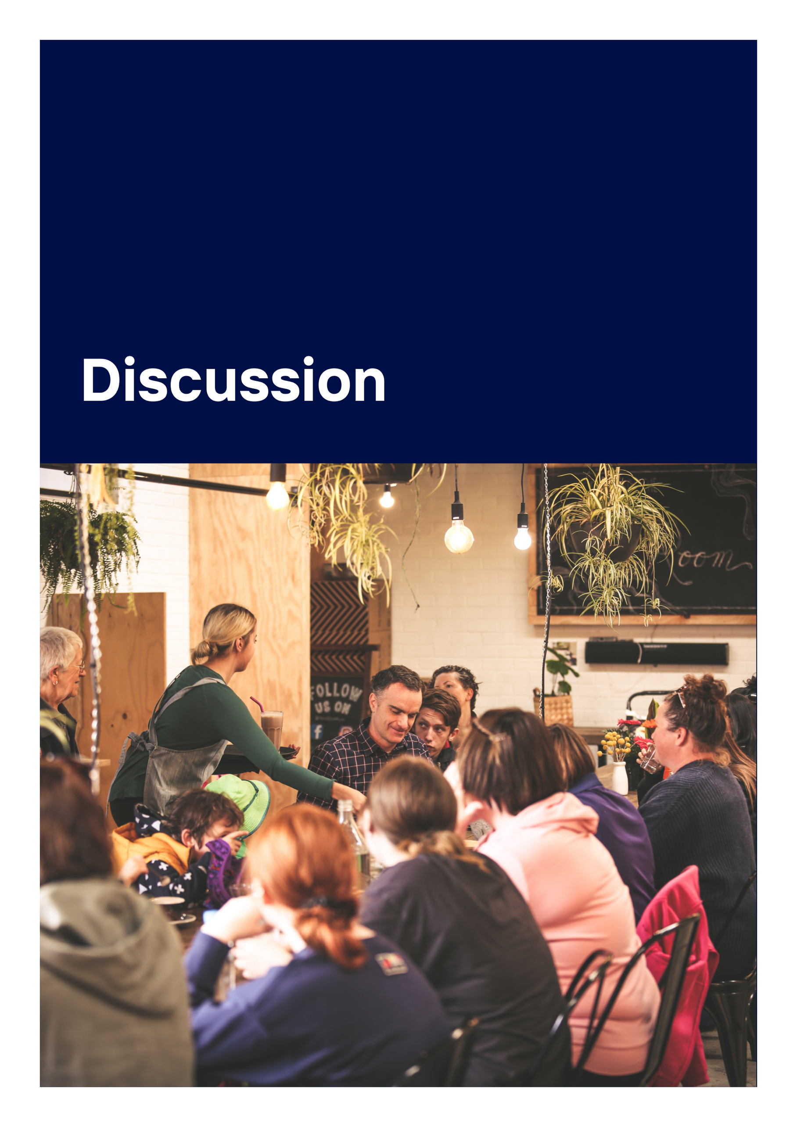

4. Discussion
The overarching narrative within focus groups and interviews conceptualizing the potential impact on the social determinants of health, reflected social enterprise characteristics impacting at the individual and intermediate level. These were organisational characteristics such as the provision of safe and supportive working environments (e.g., individualised support, flexible working arrangements), where beneficiaries and providers alike felt mutually valued and respected. For beneficiaries’ access to this environment developed knowledge and skills that enabled forward planning. At the same time, strong interpersonal relationships in multiple directions between stakeholders, engendered a sense of belonging empowering individuals to find their ‘voice’. Amongst this was the high value placed on beneficiaries’ and provider stakeholders’ capacity to act as role models. Development of this social capital was viewed as building the capacity of the social enterprise itself, its target beneficiaries, all associated stakeholders and the wider community. This was frequently referred to as ‘the ripple effect.’
Limited tools and strategies were identified as capturing these impacts, with associated processes identified as ‘ad hoc’. Most of the discussion reflected the many challenges to creating a sustainable business (e.g., time and financial resources) leaving little opportunity to focus beyond ‘numbers’ data to report against core mission outcomes (e.g., the number of trainees completing a program). Though a variety of qualitative strategies were utilised to capture individual impacts, these ‘stories’ appeared to have limited opportunity for sharing. Leveraging from existing programs, knowledge and understanding was viewed as a pathway for developing ‘fit-for-purpose’ approaches to identifying, understanding, capturing and sharing more widely the individual, intermediate and upstream impact of social enterprise on public health outcomes. The role of government, at all levels, was frequently reflected as required to achieve this.
There is a notable gap in the literature regarding long-term and broader public health outcomes of people with disabilities engaged with social enterprises. The reviewed literature highlights several key challenges and considerations in capturing the public health impacts of social enterprises. Predominantly reporting on qualitative studies, the reviewed literature identified individual and intermediate impacts of social enterprise on health and wellbeing outcomes. Similar to data discussed above, the literature often captured the influence of context, the working environment and interpersonal relationships on health and wellbeing outcomes.
Though the studies reflected a range of disability diagnoses amongst social enterprise beneficiaries, they focussed on mental health outcomes. Most studies were presented as applied research rather than evaluation reports, providing inconsistent evaluation evidence. The few looking at evaluation reports or practices were instances of external evaluators applying established program evaluation methods to identify social enterprise’ impacts or outcomes on the social determinants of health. Few studies looked at long-term and wider individual, community or public health outcomes. Those that did indicated inconsistency of evaluative evidence, associated with the complexity and resource intensive nature of current evaluation practices. These were not viewed as ‘fit-for-purpose’ for use by social enterprise providers or stakeholders, identified as - time consuming, resource intensive and requiring skills not consistently available in most social enterprises.
This need for ‘fit-for-purpose’ approaches to identify, understand, capture and share the individual, intermediate and upstream impacts of social enterprises on social determinants of health is consistent with the views expressed in consultations. Such approaches should be designed to be less resource-intensive, more accessible, and capable of providing consistent evaluation evidence meaningful to all stakeholders. Equally consistent across consultations and the reviewed literature is the view that social enterprise beneficiaries need to be at the centre of evaluation activities. This ensures that the type and quality of any impacts attributed to their engagement with the social enterprise are accurately identified and assessed.
Noting: As our project was concluding, a new online platform – Seedkit (https://seedkit.com.au/), was launched. Developed in Australia by the Centre for Social Impact at Swinburne and the Melbourne Social Equity Institute in collaboration with stakeholders. Not for profit and free to users, Seedkit aims to support social enterprises to document, measure and communicate their social impacts to employees, boards, funders and customers. How it may specifically contribute to capturing the public health impact of social enterprises for people with disability is yet to be understood, but the potential may exist within this innovative platform.

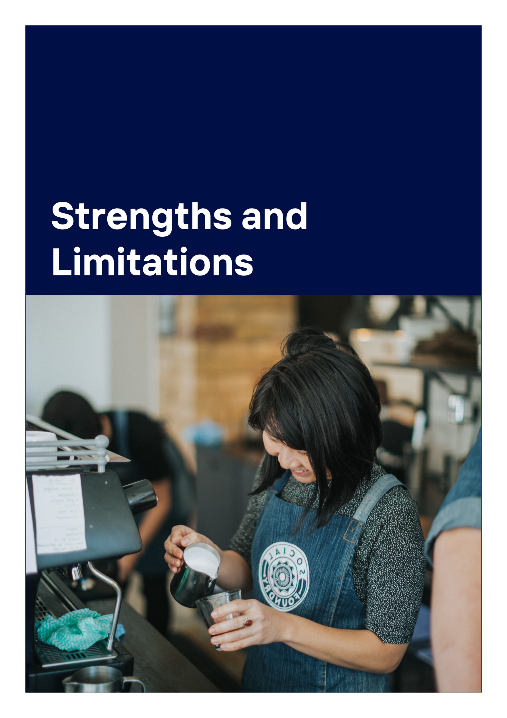

5. Strengths & limitations
In this emerging area of research, our narrative review and synthesis was strengthened by the diversity of project team members and the expertise offered through the advisory group. The overall design allowed us to approach the study from a previously unexplored perspective.
In the absence of literature that we could identify as directly responding to our first research question, our research design incorporating key stakeholder consultation and coupled with key themes identified in phase 1 consultations, we were able to widen our scope to identify studies that included examination or discussion or evaluation of health and wellbeing outcomes, or impact on social determinants of health or health inequities. We also broadened our scope to consider the perspective of any social enterprise stakeholder on outcomes for beneficiaries with disability.
Our included limits imposed by both our primary interest in people with disability, and the resourced scope of the review, may mean we have not captured literature discussing how social enterprises evaluate or measure their impact on public health more broadly. Given the concept of social enterprises gained significant prominence in the late 20th century, we may have missed some relevant studies by limiting to the most recent past decade.

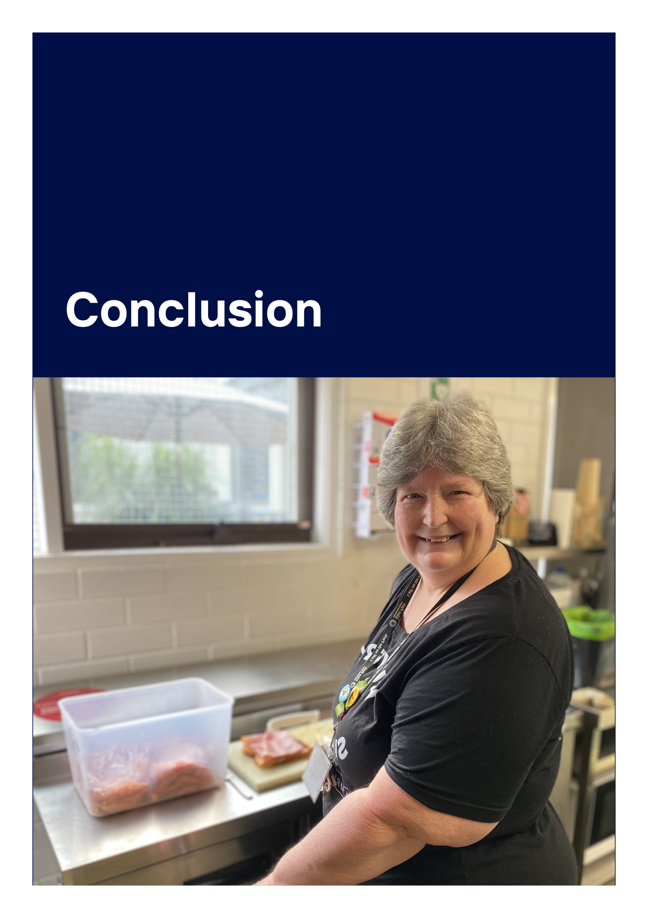

6. Conclusion
In conclusion, while social enterprises have demonstrated significant impacts on individual and intermediate health and wellbeing outcomes, capturing these impacts remains challenging. The current reliance on qualitative studies and applied research, coupled with the resource-intensive nature of formal evaluations, has led to inconsistent evaluation evidence. To address these challenges, there is a clear need for fit-for-purpose evaluation approaches that are accessible, sustainable, and capable of providing consistent and meaningful insights relevant to all stakeholders.
By developing and implementing such evaluation approaches, social enterprises can better understand and communicate their impacts on social determinants of health. This will not only enhance their ability to demonstrate value to stakeholders but also support their ongoing efforts to improve health and wellbeing outcomes for their beneficiaries. Central to this process is the involvement of beneficiaries in evaluation activities, ensuring that their experiences and outcomes are accurately captured and valued. Through these efforts, social enterprises can continue to play a vital role in promoting public health and wellbeing within their communities, and more specifically for people with disabilities.
Intermediate and long-term public health outcomes require further investigation. Future research may include:
- Research examining what characteristics of a social enterprise are required to inform its theory of change, in order that it contributes knowledge of the broader social enterprise sector public health impact, recognising this knowledge development occurs over time requiring longitudinal studies.
- Research examining the development of interpersonal relationships and the experience of role-modelling includes the potential for multidirectional impacts on health and wellbeing outcomes for beneficiaries.
- Research exploring how participation by beneficiaries in identification, measurement and communication of social enterprise impacts contributes to their participation in the social enterprise.
- Research exploring how to support the implementation of accessible and sustainable evaluation approaches that generate consistent and meaningful evaluation evidence.



References
Ahnquist, J., Wamala, S. P., & Lindstrom, M. (2012). Social determinants of health - A question of social or economic capital? Interaction effects of socioeconomic factors on health outcomes. Social Science and Medicine, 74(6), 930–939. https://doi.org/10.1016/j.socscimed.2011.11.026
Aromataris, E., Fernandez, R., Godfrey, C. M., Holly, C., Khalil, H., & Tungpunkom, P. (2015). Summarizing systematic reviews. International Journal of Evidence-Based Healthcare, 13(3), 132–140. https://doi.org/10.1097/XEB.0000000000000055
Australian Bureau of Statistics. (2018, December 12). National Health Survey: First results. https://www.abs.gov.au/statistics/health/health-conditions-and-risks/national-health-survey/2017-18
Australian Government. (2023). Working Future: The Australian Government’s White Paper on Jobs and Opportunities.
Australian Government, D. of S. S. (2023a). Social Enterprise Development Initiative. dss.gov.au/social-impact-investing/social-enterprise-development-initiative
Australian Government, D. of S. S. (2023b, September 8). Social impact investing. https://www.dss.gov.au/social-impact-investing
Bagnoli, L., & Megali, C. (2011). Measuring performance in social enterprises. Nonprofit and Voluntary Sector Quarterly, 40(1), 149–165. https://doi.org/10.1177/0899764009351111
Bornstein, D., & Davis, S. (2010). Social Entrepreneurship: What Everyone Needs to Know. Oxford University Press, Incorporated.
Caló, F., Roy, M. J., Donaldson, C., Teasdale, S., & Baglioni, S. (2019). Exploring the contribution of social enterprise to health and social care: A realist evaluation. Social Science and Medicine, 222, 154–161. https://doi.org/10.1016/j.socscimed.2019.01.007
Caló, F., Roy, M. J., Donaldson, C., Teasdale, S., & Baglioni, S. (2021). Evidencing the contribution of social enterprise to health and social care: approaches and considerations. Social Enterprise Journal, 17(1), 140–155. https://doi.org/10.1108/SEJ-11-2020-0114
Cho, S., Kim, M. A., & Kwon, S. Il. (2019). Using the photovoice method to understand experiences of people with physical disabilities working in social enterprises. Disability and Health Journal, 12(4), 685–693. https://doi.org/10.1016/j.dhjo.2019.03.011
Chui, C. H. K., Chan, C. H. O. N., & Chandra, Y. (2023). The role of social enterprises in facilitating labour market integration for people with disabilities: A convenient deflection from policy mainstreaming? Journal of Social Policy, 52(1), 176–196. https://doi.org/10.1017/S0047279421000490
Commonwealth of Australia, D. of S. S. (2021). Australia’s Disability Strategy 2021-2031. disabilitygateway.gov.au/sites/default/files/document/2021-11/1786-australias-disability.pdf
European Commission. Directorate-General for Employment, S. A. and Inclusion., & Organisation for Economic Co-operation and Development. (2015). Policy brief on Social Impact Measurement for Social Enterprises, Policies for Social Entrepreneurship. Publications Office.
Farmer, J., Cotta, T., Kilpatrick, S., Barraket, J., Brennan-Horley, C., McKinnon, K., Adler, V., Kamstra, P., Emery, S., Kennedy, M., Munoz, S.-A., & Roy, M. J. (2020). Mapping the impact of social enterprise on disadvantaged individuals and communities in Australia’s regional cities. https://doi.org/10.25916/5ea919c957bac
Fioramonti, L., Coscieme, L., Costanza, R., Kubiszewski, I., Trebeck, K., Wallis, S., Roberts, D., Mortensen, L. F., Pickett, K. E., Wilkinson, R., Ragnarsdottír, K. V., McGlade, J., Lovins, H., & De Vogli, R. (2022). Wellbeing economy: An effective paradigm to mainstream post-growth policies? Ecological Economics, 192. https://doi.org/10.1016/j.ecolecon.2021.107261
Galvin, M. D., & Iannotti, L. (2015). Social Enterprise and Development: The KickStart Model. Voluntas, 26(2), 421–441. https://doi.org/10.1007/s11266-013-9424-z
Glen Park Community Centre. (2020). About Cafe on the Park. https://www.glenparkcc.com.au/social-enterprise-cafe-s/cafe-on-the-park
Government, A. (2023). Working Future, The Australian Government’s White Paper on Jobs and Opportunities. http://www.pmc.gov.au/government/commonwealth-coat-arms
Green, C., Dickinson, H., & Carey, G. (2021). Debates in disability and Health Policy: Health inequities and the social determinants of health for Australians with disability. The University of Melbourne. Online Resource. https://doi.org/10.26188/16564002.v2
Harrison, M. (2022). Game on for collaborative learning. Pursuit.
Joyce, A., Elmes, A., Campbell, P., Moussa, B., Suchowerska, R., Barraket, J., & Carey, G. (2022). The health and well-being impacts of a work integration social enterprise from a systems perspective. Health Promotion International, 37(1). https://doi.org/10.1093/heapro/daab052
Kerlin, J. A. (2010). A Comparative Analysis of the Global Emergence of Social Enterprise. Voluntas: International Journal of Voluntary and Nonprofit Organizations, 21(2), 162–179. https://doi.org/10.1007/s
Kitson, A., Marshall, A., Bassett, K., & Zeitz, K. (2013). What are the core elements of patient-centred care? A narrative review and synthesis of the literature from health policy, medicine and nursing. In Journal of Advanced Nursing (Vol. 69, Issue 1, pp. 4–15). https://doi.org/10.1111/j.1365-2648.2012.06064.x
Klarin, A., & Suseno, Y. (2023). An Integrative Literature Review of Social Entrepreneurship Research: Mapping the Literature and Future Research Directions. In Business and Society (Vol. 62, Issue 3, pp. 565–611). SAGE Publications Ltd. https://doi.org/10.1177/00076503221101611
Kordsmeyer, A. C., Lengen, J. C., Kiepe, N., Harth, V., & Mache, S. (2020). Working conditions in social firms and health promotion interventions in relation to employees’ health and work-related outcomes—A scoping review. In International Journal of Environmental Research and Public Health (Vol. 17, Issue 11, pp. 1–26). MDPI AG. https://doi.org/10.3390/ijerph17113963
Kordsmeyer, A.-C., Efimov, I., Lengen, J. C., Flothow, A., Nienhaus, A., Harth, V., & Mache, S. (2022). Balancing social and economic factors - explorative qualitative analysis of working conditions of supervisors in German social firms. Journal of Occupational Medicine and Toxicology, 17(1), 4. https://doi.org/10.1186/s12995-021-00342-y
Laratta, R. (2016). An Interface Between Mental Health Systems and the Community: Italian Social Cooperatives. Journal of Policy Practice, 15(1–2), 102–115. https://doi.org/10.1080/15588742.2016.1109970
Lysaght, R., Ghaderi, G., Milley, P., & Labelle, P. R. (2022). Best practices in evaluating work integration social enterprises for persons with intellectual disabilities: A scoping review. Journal of Policy and Practice in Intellectual Disabilities, 19(4), 431–440. https://doi.org/10.1111/jppi.12439
Macaulay, B., Roy, M. J., Donaldson, C., Teasdale, S., & Kay, A. (2018). Conceptualizing the health and well-being impacts of social enterprise: A UK-based study. Health Promotion International, 33(5), 748–759. https://doi.org/10.1093/heapro/dax009
Mason, C., Barraket, J., Friel, S., O’Rourke, K., & Stenta, C. P. (2015). Social innovation for the promotion of health equity. Health Promotion International, 30, ii116–ii125. https://doi.org/10.1093/heapro/dav076
Mays, N., Pope, C., & Popay, J. (2005). Systematically reviewing qualitative and quantitative evidence to inform management and policymaking in the health field. In Journal of Health Services Research & Policy (Vol. 10).
McKinnon, K., Kennedy, M., & De Cotta, T. (2022). Social enterprises and community wellbeing in regional Australia. Journal of Sociology, 58(2), 161–177. https://doi.org/10.1177/14407833211035839
Nha HONG, Q., Pluye, P., Fàbregues, S., Bartlett, G., Boardman, F., Cargo, M., Dagenais, P., Gagnon, M.-P., Griffiths, F., Nicolau, B., O’Cathain, A., Rousseau, M.-C., & Vedel, I. (2018). MIXED METHODS APPRAISAL TOOL (MMAT) VERSION 2018 User guide. http://mixedmethodsappraisaltoolpublic.pbworks.com/
Nicholls, A. (Ed.). (2006). Social Entrepreneurship: New Models of Sustainable Social Change. Oxford University Press, Incorporated.
Philanthropy Australia. (2023, May 29). Media Release: New alliance to help drive more impact investing in Australia. https://www.philanthropy.org.au/news-and-stories/media-release-new-alliance-to-help-drive-more-impact-investing-in-australia/
Popay, J., Roberts, H., Sowden, A., Petticrew, M., Arai, L., Rodgers, M., Britten, N., Roen, K., & Duffy, S. (2006). Guidance on the Conduct of Narrative Synthesis in Systematic Reviews A Product from the ESRC Methods Programme Peninsula Medical School, Universities of Exeter and Plymouth.
Qian-Khoo, J. X., Hiruy, K., Hutton, R. W. A., & Barraket, J. (2022). A Systematic Review of Meta-Evaluations: Lessons for Evaluation and Impact Analysis. American Journal of Evaluation, 43(3), 394–411. https://doi.org/10.1177/10982140211018276
Roy, M. J., Donaldson, C., Baker, R., & Kerr, S. (2014). The potential of social enterprise to enhance health and well-being: A model and systematic review. Social Science and Medicine, 123, 182–193. https://doi.org/10.1016/j.socscimed.2014.07.031
Roy, M. J., Lysaght, R., & Krupa, T. M. (2017). Action on the social determinants of health through social enterprise. Canadian Medical Association Journal, 189(11), E440–E441. https://doi.org/10.1503/cmaj.160864
Saebi, T., Foss, N. J., & Linder, S. (2019). Social Entrepreneurship Research: Past Achievements and Future Promises. Journal of Management, 45(1), 70–95. https://doi.org/10.1177/0149206318793196
Shipton, D., Sarica, S., Craig, N., McCartney, G., Katikireddi, S. V., Roy, G., McGregor, P., & Scobie, G. (2021). Knowing the goal: an inclusive economy that can address the public health challenges of our time. Journal of Epidemiology and Community Health, 75, 1129–1132. https://doi.org/10.1136/jech-2020-216070
Social Enterprise Alliance. (2013, May 2). The Case for Social Enterprise Alliance. What is Social Enterprise? Internet Archive WayBack Machine. https://web.archived.org/web/20130502080130/https:///www.se-alliance.org/what-is-social-enterprise
Suchowerska, R., Barraket, J., Qian, J., Mason, C., Farmer, J., Carey, G., Campbell, P., & Joyce, A. (2020). An Organizational Approach to Understanding How Social Enterprises Address Health Inequities: A Scoping Review. Journal of Social Entrepreneurship, 11(3), 257–281. https://doi.org/10.1080/19420676.2019.1640771
Sutton, A., Clowes, M., Preston, L., & Booth, A. (2019). Meeting the review family: exploring review types and associated information retrieval requirements. In Health Information and Libraries Journal (Vol. 36, Issue 3, pp. 202–222). Blackwell Publishing Ltd. https://doi.org/10.1111/hir.12276
Trafford, Z., van der Westhuizen, E., McDonald, S., Linegar, M., & Swartz, L. (2021). More than just assistive devices: How a south african social enterprise supports an environment of inclusion. International Journal of Environmental Research and Public Health, 18(5), 1–15. https://doi.org/10.3390/ijerph18052655
VicHealth. (2015). Promoting equity through social innovation. http://heapro.oxfordjournals.org/
Victorian State Government, D. of J. P. and R. (2021). Victorian Social Enterprise Strategy 2021-2025. https://djpr.vic.gov.au/ data/assets/pdf file/0018/2036205/DJPR-Victorian-Social-Enterprise-Strategy.pdf
Villotti, P., Corbière, M., Dewa, C. S., Fraccaroli, F., Sultan-Taïeb, H., Zaniboni, S., & Lecomte, T. (2018). A serial mediation model of workplace social support on work productivity: the role of self-stigma and job tenure self-efficacy in people with severe mental disorders. Disability and Rehabilitation, 40(26), 3113–3119. https://doi.org/10.1080/09638288.2017.1377294
Villotti, P., Corbière, M., Fossey, E., Fraccaroli, F., Lecomte, T., & Harvey, C. (2017). Work Accommodations and Natural Supports for Employees with Severe Mental Illness in Social Businesses: An International Comparison. Community Mental Health Journal, 53(7), 864–870. https://doi.org/10.1007/s10597-016-0068-5
Whitelaw, S., Bell, A., Mackay, A., & Hall, H. (2023). Fostering resilience in young people with intellectual disabilities using a ‘settings’ approach. Journal of Intellectual Disabilities. https://doi.org/10.1177/17446295231168186
Wilson, E., Qian-Khoo, J., Campain, R., Joyce, A., & Kelly, J. (2021). Summary Report. Mapping the employment support interventions for people with work restriction in Australia.

Appendix

Appendix 1: Critical Appraisal Checklists

- Mixed Methods Appraisal Tool (MMAT) Version 2018
 |  | Vilotti et al. (2018) | Kordsmeyer et al. (2022) | Cho et al. (2019) | Vilotti et al. (2017) | Chui et al. (2023) | McKinnon et al. (2022) | Larratta, R. (2016) | Caló et al. (2019) | Caló et al. (2021) | Macaulay et al. (2018) | Whitelaw et al. (2023) | Joyce et al. (2022)
Screening questions  (for all types) | S1. Are there clear research questions? | ✔️ | ✔️ | ✔️ | ✔️ | ✔️ | ✔️ | ✔️ | ✔️ | ✔️ | ✔️ | ✔️ | ✔️
Screening questions  (for all types) | S2. Do the collected data allow to address the research questions? | ✔️ | ✔️ | ✔️ | ✔️ | ✔️ | ✔️ | ✔️ | ✔️ | ✔️ | ✔️ | ✔️ | ✔️
Qualitative | 1.1. Is the qualitative approach appropriate to answer the research question? |  | ✔️ | ✔️ |  | ✔️ | ✔️ | ✔️ | ✔️ |  | ✔️ | ✔️ | ✔️
Qualitative | 1.2. Are the qualitative data collection methods adequate to address the research question? |  | ✔️ | ✔️ |  | ✔️ | ✔️ | - | - |  | ✔️ | ✔️ | ✔️
Qualitative | 1.3. Are the findings adequately derived from the data? |  | ✔️ | ✔️ |  | ✔️ | ✔️ | ✔️ | ✔️ |  | ✔️ | ✔️ | ✔️
Qualitative | 1.4. Is the interpretation of results sufficiently substantiated by data? |  | ✔️ | ✔️ |  | ✔️ | ✔️ | - | ✔️ |  | ✔️ | ✔️ | ✔️
Qualitative | 1.5. Is there coherence between qualitative data sources, collection, analysis, and interpretation? |  | ✔️ | ✔️ |  | ✔️ | ✔️ | ✔️ | ✔️ |  | ✔️ | ✔️ | ✔️
Quantitative randomised controlled trials | 2.1. Is randomization appropriately performed?
Quantitative randomised controlled trials | 2.2. Are the groups comparable at baseline?
Quantitative randomised controlled trials | 2.3. Are there complete outcome data?
Quantitative randomised controlled trials | 2.4. Are outcome assessors blinded to the intervention provided?
Quantitative randomised controlled trials | 2.5. Did the participants adhere to the assigned intervention?
Quantitative non-randomised | 3.1. Are the participants representative of the target population?
Quantitative non-randomised | 3.2. Are measurements appropriate regarding both the outcome and intervention (or exposure)?
Quantitative non-randomised | 3.3. Are there complete outcome data?
Quantitative non-randomised | 3.4. Are the confounders accounted for in the design and analysis?
Quantitative non-randomised | 3.5. During the study period, is the intervention administered (or exposure occurred) as intended?
Quantitative descriptive | 4.1. Is the sampling strategy relevant to address the research question? | ✔️ |  |  | ✔️
Quantitative descriptive | 4.2. Is the sample representative of the target population? | ✔️ |  |  | ✔️
Quantitative descriptive | 4.3. Are the measurements appropriate? | ✔️ |  |  | ✔️
Quantitative descriptive | 4.4. Is the risk of nonresponse bias low? | - |  |  | ✔️
Quantitative descriptive | 4.5. Is the statistical analysis appropriate to answer the research question? | ✔️ |  |  | ✔️
Mixed methods | 5.1. Is there an adequate rationale for using a mixed methods design to address the research question? |  |  |  |  |  |  |  |  | ✔️
Mixed methods | 5.2. Are the different components of the study effectively integrated to answer the research question? |  |  |  |  |  |  |  |  | ✔️
Mixed methods | 5.3. Are the outputs of the integration of qualitative and quantitative components adequately interpreted? |  |  |  |  |  |  |  |  | ✔️
Mixed methods | 5.4. Are divergences and inconsistencies between quantitative and qualitative results adequately addressed? |  |  |  |  |  |  |  |  | ✔️
Mixed methods | 5.5. Do the different components of the study adhere to the quality criteria of each tradition of the methods involved? |  |  |  |  |  |  |  |  | ✔️
✔️= Yes, ✘= no, - = Cannot tell
- JBI Critical Appraisal Checklist for Systematic/Scoping Reviews
 | Kordsmeyer et al. (2020) | Lysaght et al. (2022) | Mason et al. (2015) | Roy et al. (2014) | Suchowerska et al. (2020)
Is the review question clearly and explicitly stated? | Y | Y | Y | Y | Y
Were the inclusion criteria appropriate for the review question? | U | Y | Y | Y | Y
Was the search strategy appropriate? | Y | Y | Y | Y | Y
Were the sources and resources used to search for studies adequate? | Y | Y | Y | Y | Y
Were the criteria for appraising studies appropriate? | Y | U | Y | Y | Y
Was critical appraisal conducted by two or more reviewers independently? | Y | Y | U | Y | Y
Were there methods to minimize errors in data extraction? | Y | Y | Y | Y | Y
Were the methods used to combine studies appropriate? | Y | Y | Y | Y | Y
Was the likelihood of publication bias assessed? | N | N | U | U | U
Were recommendations for policy and/or practice supported by the reported data? | Y | Y | Y | Y | Y
Were the specific directives for new research appropriate? | Y | Y | Y | Y | Y
**Yes=Y, No=N, Unclear=U, Not applicable=NA

- AACODS |  |  | Trafford et al. (2021) | Roy et al. (2017) | Klarin et al. (2023) | Australian Government (2023) | European Commission OECD (2015) | VicHealth (2015) | Wilson et al. (2021)
Authority | Identifying who is responsible for the intellectual content.
Authority | Individual author:
Authority | • Associated with a reputable organisation?  • Professional qualifications or considerable experience?  • Produced/published other work (grey/black) in the field?  • Recognised expert, identified in other sources?  • Cited by others? (use Google Scholar as a quick check)  • Higher degree student under “expert” supervision?
Authority | Organisation or group:
Authority | • Is the organisation reputable? (e.g. W.H.O)  • Is the organisation an authority in the field? |  | ?  Y | Y  Y | Y  Y | Y  Y | Y  Y | Y  Y | Y  Y
Authority | In all cases:
Authority | • Does the item have a detailed reference list or bibliography? |  | Y | Y | Y | Y | Y | Y | Y
Accuracy | •  •  •  •  •  •  •  •  •  •  •  •  • | Does the item have a clearly stated aim or brief?  If so, is this met?  Does it have a stated methodology? If so, is it adhered to?  Has it been peer-reviewed?  Has it been edited by a reputable authority?  Supported by authoritative, documented references or credible sources?  Is it representative of work in the field?  If No, is it a valid counterbalance?  Is any data collection explicit and appropriate for the research?  If item is secondary material (e.g. a policy brief of a technical report) refer to the original.  Is it an accurate, unbiased interpretation or analysis? | Y  Y  Y  Y  Y  N  ?  N  ?  N/A  ? | Y  Y  N/A  Y  Y  Y  Y  N/A  Y | Y  Y  Y  Y  Y  Y  Y  N  Y  Y  Y | Y  Y  N/A  N  Y  Y  Y  Y  ? | Y  Y  N/A  N  Y  Y  Y  Y  Y | Y  Y  N/A  N  Y  Y  Y  N/A  Y | Y  Y  Y  Y  Y  Y  Y  Y  Y  Y
Coverage | All items have parameters which define their content coverage. These limits might mean that a work refers to a particular population group, or that it excludes certain types of publication. A report could be designed to answer a particular question or be based on statistics from a particular survey.  • Are any limits clearly stated? |  | Y | Y | Y | Y | Y | Y | Y
Objectivity | It is important to identify bias, particularly if it is unstated or unacknowledged.  - Opinion, expert or otherwise, is still opinion: is the author’s standpoint clear?  - Does the work seem to be balanced in presentation? |  | Y  Y | Y  Y | Y  Y | Y  Y | Y  Y | Y  Y | Y  Y
Date | For the item to inform your research, it needs to have a date that confirms relevance.  - Does the item have a clearly stated date related to content? No easily discernible date is a strong concern.  - If no date is given, but can be closely ascertained, is there a valid reason for its absence?  - Check the bibliography: have key contemporary material been included? |  | Y  Y | Y  Y | Y  Y | Y  Y | Y  Y | Y  Y | Y  Y
Significance | This is a value judgment of the item, in the context of the relevant research area.  - Is the item meaningful? (this incorporates feasibility, utility, and relevance)  - Does it add context?  - Does it enrich or add something unique to the research?  - Does it strengthen or refute a current position?  - Would the research area be lesser without it?  - Is it integral, representative, typical?  - Does it have impact? (in the sense of influencing the work or behaviour of others) |  | Y  Y  Y  ?  ?  N  ? | Y  Y  ?  Y  ?  Y  Y | Y  Y  Y  Y  Y  ?  Y | Y  Y  Y  Y  Y  Y  Y | Y  Y  Y  Y  Y  Y  Y | Y  Y  Y  Y  Y  Y  Y | Y  Y  Y  Y  Y  ?  Y
Yes=Y, No=N, Unclear=?

Appendix 2: Focus Group Participant Consent Form

Project: Towards developing innovative evaluation approaches to measure the public health impact of social enterprises.
Coordinating Investigator: A/Prof Lucio Naccarella
Tel: +61407 006 459 Email: l.naccarella@unimelb.edu.au
Additional Researchers:
Ms Marie Huska (Co-coordinating Investigator) Email: marie.huska@unimelb.edu.au
Ms Jessica Rowlings (Co-coordinating Investigator) Email: jessica.rowlings@unimelb.edu.au
Ms Heidi Butler-Moore (Investigator) Email: heidibutler@glenparkcc.com.au
Mr Chris Riseley (Investigator) Email: Chris.Riseley@maroondah.vic.gov.au
Ms Sue Lee Theel (Investigator) Email: suelee@socialfoundry.org.au
Dr Alexandra Devine (Investigator) Email: alexandra.devine@unimelb.edu.au
Dr Sue Olney (Investigator) Email: s.olney@unimelb.edu.au
Dr Matthew Harrison (Investigator) Email: matthew.harrison@unimelb.edu.au
Dr Jemimah Ride (Investigator) Email: jemimah.ride@monash.edu

Name of Participant:
1. I consent to participate in this project, the details of which have been explained to me, and I have been provided with a written plain language statement to keep.
2. I understand that the purpose of this research is to investigate whether and how social enterprises currently think about, assess and measure their public health impact, particularly for people who face barriers to employment such as people with disability.
3. I understand that my participation in this project is for research purposes only.
4. I acknowledge that the possible effects of participating in this research project have been explained to my satisfaction.
5. In this project I will be required to participate in 2 focus/discussion groups, each approximately 2 months apart, each approximately 2 hours long.
6. I understand that my focus/discussion group discussions will be audio recorded.
7. I understand that my participation is voluntary and that I am free to withdraw from this project anytime without explanation or prejudice and to withdraw any unprocessed data that I have provided.
8. I understand that the data from this research will be stored at the University of Melbourne and will be destroyed 5 years after publication.
9. I have been informed that the confidentiality of the information I provide will be safeguarded subject to any legal requirements; my data will be password protected and accessible only by the named researchers.
10. I understand that given the small number of participants involved in the study, it may not be possible to guarantee my anonymity.
11. I understand that after I sign and return this consent form, it will be retained by the researcher.
Participant Signature: Date:

Appendix 3: Focus Group Participant Verbal Consent
Project: Towards developing innovative evaluation approaches to measure the public health impact of social enterprises.
Coordinating Investigator: A/Prof Lucio Naccarella
Tel: +61407 006 459 Email: l.naccarella@unimelb.edu.au
Additional Researchers:
Ms Marie Huska (Co-coordinating Investigator) Email: marie.huska@unimelb.edu.au
Ms Jessica Rowlings (Co-coordinating Investigator) Email: jessica.rowlings@unimelb.edu.au
Ms Heidi Butler-Moore (Investigator) Email: heidibutler@glenparkcc.com.au
Mr Chris Riseley (Investigator) Email: Chris.Riseley@maroondah.vic.gov.au
Ms Sue Lee Theel (Investigator) Email: suelee@socialfoundry.org.au
Dr Alexandra Devine (Investigator) Email: alexandra.devine@unimelb.edu.au
Dr Sue Olney (Investigator) Email: s.olney@unimelb.edu.au
Dr Matthew Harrison (Investigator) Email: matthew.harrison@unimelb.edu.au
Dr Jemimah Ride (Investigator) Email: jemimah.ride@monash.edu

The table below lists A) what the researcher has to do and B) the key information to be communicated to each participant, BEFORE commencing the study.
A ticked box indicates that each task has been undertaken and each item of information has been communicated and understood.
Table A – Tasks to be completed | Tick
The Plain Language Statement has been read to the participant in a way that they understand.
The participant has had an opportunity to ask questions.
The participant can describe back to the researcher what this research project is about.
Table B - Participant to confirm the following:
1. The Plain Language Statement has been read to me in a way that I can understand.
2. I understand that the purpose of this research is to investigate whether and how social enterprises currently think about, assess and measure their public health impact for people facing barriers to employment, particularly people with disability.
3. I understand I am agreeing to participate in 2 focus/discussion groups, each approximately 2 months apart, each approximately 2 hours long, and that Marie Huska, the researcher leading the focus group discussion will audio record our talking, and write notes, and that I can have a support person with me.
4. I understand the possible good and bad effects participating in this research may have for me.
5. I understand that after I sign and return this consent form it will be kept by the researcher, but I can ask for a copy of it.
6. I have had an opportunity to ask questions and I am satisfied with the answers I have received.
7. I freely agree to participate in this project and that both (approximately 2 hour) focus/discussion groups are to be audio-recorded.
8. I acknowledge that:
- my participation in this research is voluntary and I am free to withdraw from this project anytime without explanation or prejudice and to withdraw any unprocessed data that I have provided, and
- the project is for the purpose of research.
9. I have been informed that the confidentiality of the information I provide will be safeguarded subject to any legal requirements; my information will be password protected and accessible only by the named researchers.
10. I understand that given the small number of participants involved in the study, it may not be possible to guarantee my anonymity.
11. I have been informed that I can request a copy of the research findings.

Name of participant:
Signature of researcher:
to indicate the participant has verbally consented to participate in the project
Name of witness:
Relationship of witness to the Participant:
Signature of witness:
to indicate the participant has verbally consented to participate in the project
Date:

Appendix 4: Interview Participant Consent Form
Project: Towards developing innovative evaluation approaches to measure the public health impact of social enterprises.
Coordinating Investigator: A/Prof Lucio Naccarella
Tel: +61407 006 459 Email: l.naccarella@unimelb.edu.au
Additional Researchers:
Ms Marie Huska (Co-coordinating Investigator) Email: marie.huska@unimelb.edu.au
Ms Jessica Rowlings (Co-coordinating Investigator) Email: jessica.rowlings@unimelb.edu.au
Ms Heidi Butler-Moore (Investigator) Email: heidibutler@glenparkcc.com.au
Mr Chris Riseley (Investigator) Email: Chris.Riseley@maroondah.vic.gov.au
Ms Sue Lee Theel (Investigator) Email: suelee@socialfoundry.org.au
Dr Alexandra Devine (Investigator) Email: alexandra.devine@unimelb.edu.au
Dr Sue Olney (Investigator) Email: s.olney@unimelb.edu.au
Dr Matthew Harrison (Investigator) Email: matthew.harrison@unimelb.edu.au
Dr Jemimah Ride (Investigator) Email: jemimah.ride@monash.edu

Name of Participant:

1. I consent to participate in this project, the details of which have been explained to me, and I have been provided with a written plain language statement to keep.
2. I understand that the purpose of this research is to investigate whether and how social enterprises currently think about, assess and measure their public health impact, particularly for people with disability.
3. I understand that my participation in this project is for research purposes only.
4. I acknowledge that the possible effects of participating in this research project have been explained to my satisfaction.
5. In this project I will be required to participate in 2 individual interviews, each approximately 2 months apart, each of approximately 30 minutes duration.
6. I understand that my interview may be audio recorded.
7. I understand that my participation is voluntary and that I am free to withdraw from this project anytime without explanation or prejudice and to withdraw any unprocessed data that I have provided.
8. I understand that the data from this research will be stored at the University of Melbourne and will be destroyed 5 years after publication.
9. I have been informed that the confidentiality of the information I provide will be safeguarded subject to any legal requirements; my data will be password protected and accessible only by the named researchers.
10. I understand that given the small number of participants involved in the study, it may not be possible to guarantee my anonymity.
11. I understand that after I sign and return this consent form, it will be retained by the researcher.

Participant Signature:
Date:

Appendix 5: Research Flyer Template – Focus Group Participants

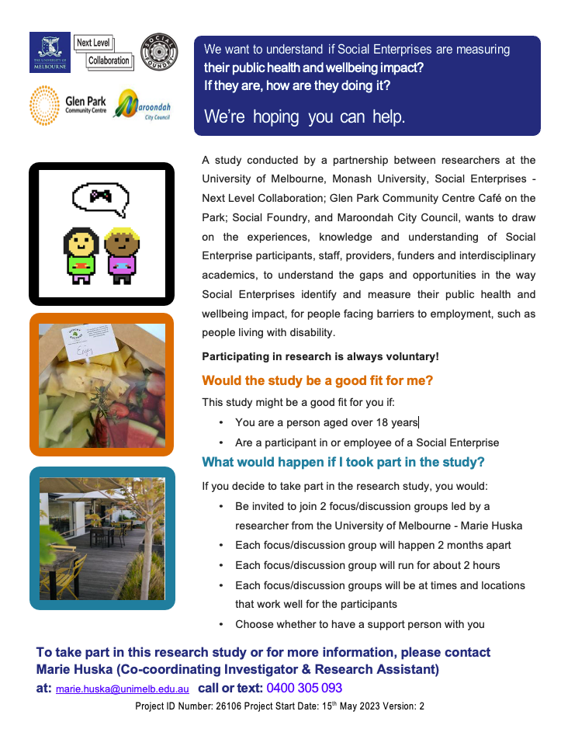

Appendix 6: Research Flyer Template – Interview Participants

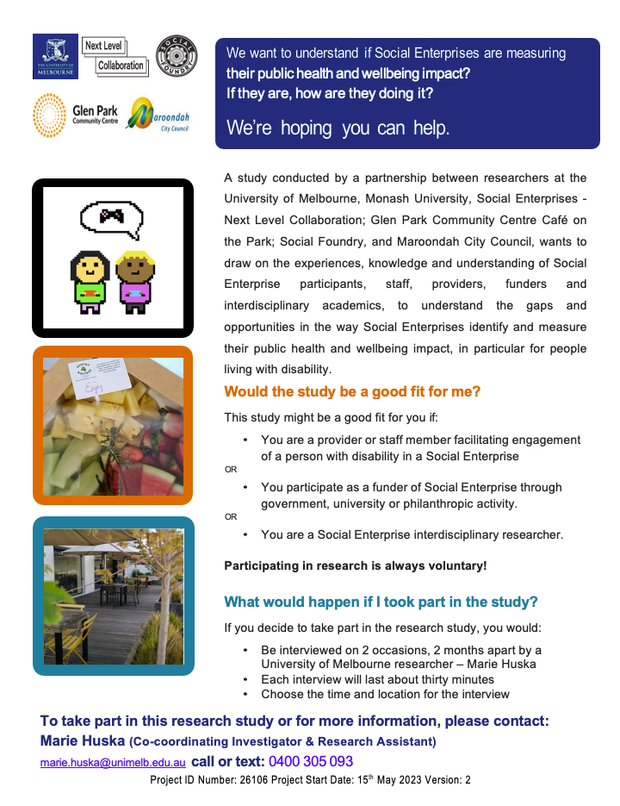

Appendix 7: Plain Language Statement
Project: Towards developing innovative evaluation approaches to measure the public health impact of social enterprises.
Coordinating Investigator: Associate Professor Lucio Naccarella Tel: +61407 006 459 Email: l.naccarella@unimelb.edu.au
Information for potential participants
An invitation to participate in a project to help us understand if and how Social Enterprises identify and measure their public health impact?
Would you like to be involved in some research? It is up to you if you would like to be involved. You may ask questions about anything you don’t understand or want to know more about. If you start being involved and change your mind, you can stop at any time.
What’s the research about?
This research is interested in learning more about whether and how social enterprises currently think about, assess and measure their public health impact, particularly for people who face barriers to employment such as people with disability.
Who is doing this research?
Public health, education, evaluation and policy researchers from Melbourne and Monash universities are collaborating with community partners from three Social Enterprises – Next Level Collaboration; Glen Park Community Centre Café on the Park; Social Foundry, and Maroondah City Council, to conduct this one-year research project.
This research is funded by a Melbourne Disability Institute grant.
This research has been approved by the Human Research Ethics Committee of The University of Melbourne. Project ID 26106.
Why are we doing this research?
Evidence suggests we may be able to look at social enterprises as a way of improving health outcomes for populations currently experiencing poorer health than other Australians. Understanding whether and how social enterprise impact public health outcomes could be particularly important to people such as those with disability who experience poorer health in comparison to those without disability.
However, differences in the purpose of social enterprises have led to diverse ways of assessing their impact. This makes it difficult to assess and understand the evidence on their public health impact. Social enterprise may offer a pathway towards improving the unequal health outcomes for populations such as people with disability. This could further encourage investment into social enterprises.
What will I be asked to do?
The project intends to complete a review of national and international evidence about how the health impact of social enterprise is currently identified and assessed. The review will be guided by two consultation phases. In each phase, some participants will be in focus/discussion groups, and other participants in individual interviews.
For the focus/discussion groups, researchers want to listen to people who face barriers to employment (such as people with disability) aged over 18 years, who participate in or are an employee of a social enterprise. If you use communication aids or a communication partner or would like a support person with you, you are welcome to join the research. If you decide to take part in the research, you will be invited to join two focus (discussion) group discussions led by Marie Huska from the University of Melbourne. Each focus (discussion) group will be about 2 months apart.
Participants in focus (discussion) groups will be the same for each discussion. Each focus (discussion) group will run for about 2 hours, at a time and location that work well for the group participants. It could be at your social enterprise or another private space where the group feels comfortable to talk. The focus (discussion) groups will talk about whether and how involvement in a social enterprise may impact health outcomes. Each focus (discussion) group research participant will be provided with a $100 gift voucher at the 2nd focus (discussion) group. We will also help support any travel costs up to a maximum of $80 for focus (discussion) group participants if they travel for the focus (discussion) groups.
For the interviews, researchers want to speak with those who facilitate engagement of people with disability in a social enterprise. We’d also like to speak with funders of social enterprise (e.g. government, university, philanthropy), and social enterprise interdisciplinary researchers. If taking part in the research, you will be invited to two individual interviews with either Marie Huska or Jess Rowlings from the University of Melbourne.
Each interview will be about 2 months apart and each will go for about thirty minutes, at a time and location that works well for you. The project does not have capacity to offer individual interview participants reimbursement.
What I need to know if I would like to be involved?
It is up to you if you would like to join a focus (discussion) group or be interviewed by a University of Melbourne researcher. If you would like to be involved Marie Huska will complete an informed consent form with you. If you change your mind about being involved, that’s ok too. If you do decide to stop, you WILL NOT be disadvantaged in any way.
With your permission the focus (discussion) group discussions (led by Marie Huska) or the individual interviews (with either Marie Huska or Jess Rowlings) will be audio recorded during the discussions or interviews. You can ask to turn the recorder off. Marie may write notes about key points after the focus (discussion) group discussions, and Marie or Jess may write notes during the interviews. You have the right to check the information you have provided. The research team will keep your information private. The research team won’t tell anyone whose information it is, even when they talk or write about the research. However, this is a small research project and people who know you may be able to recognise information provided by you. Only Marie and Jess, will be able to link the information you provide to your name, for example, to send you the summary of research findings. Your information will be stored safely on a computer for five years from the last time the research team writes about the research or uses it to apply for funding for further related research, and then they will destroy the information.
What are the possible benefits if I participate?
We are interested in what you have to say. This is a good opportunity for you to talk about your own experiences and share your views. This will help add to the evidence informing and guiding understanding of the gaps and opportunities within current approaches when seeking to identify and measure the public health impact, for populations currently experiencing poorer health outcomes, such as people with disability. It will also assist our understanding of what may be needed to design, develop, and implement new approaches in the identification and measurement of the public health impact of Social Enterprises.
What are the possible risks if I participate?
This research is based on conversations with you. There might be a risk that when you are thinking and talking about your experiences it could become distressing or embarrassing. When Marie or Jess is speaking with you, they can discuss the best way to offer you support if this happens.
They will check how you are feeling during and at the end of each focus (discussion) group or interview. You will be supported to leave the focus (discussion) group, or stop the interview, if needed for you to feel ok.
Who to contact if I want to be involved or know more about it?
Please contact: Marie Huska (Co-coordinating investigator & Research Assistant) via email: marie.huska@unimelb.edu.au or mob: 0400 305 093.
Who do I contact if I am not happy with something or want to complain about the research?
You can talk to Marie directly via email or mobile and talk about your worries.
If you would like to contact the Coordinating Investigator: Associate Professor Lucio Naccarella please contact him via email or mobile and talk about your worries.
Email: l.naccarella@unimelb.edu.au Tel: +61407 006 459
If you would like to contact the people who approved this project, please contact:
Research Integrity Administrator, Office of Research Ethics and Integrity, University of Melbourne, VIC 3010. Tel: +61 3 8344 1376 or Email: research-integrity@unimelb.edu.au.
All complaints will be treated confidentially. In any correspondence, please provide the name of the or ethics ID number of the research project.


