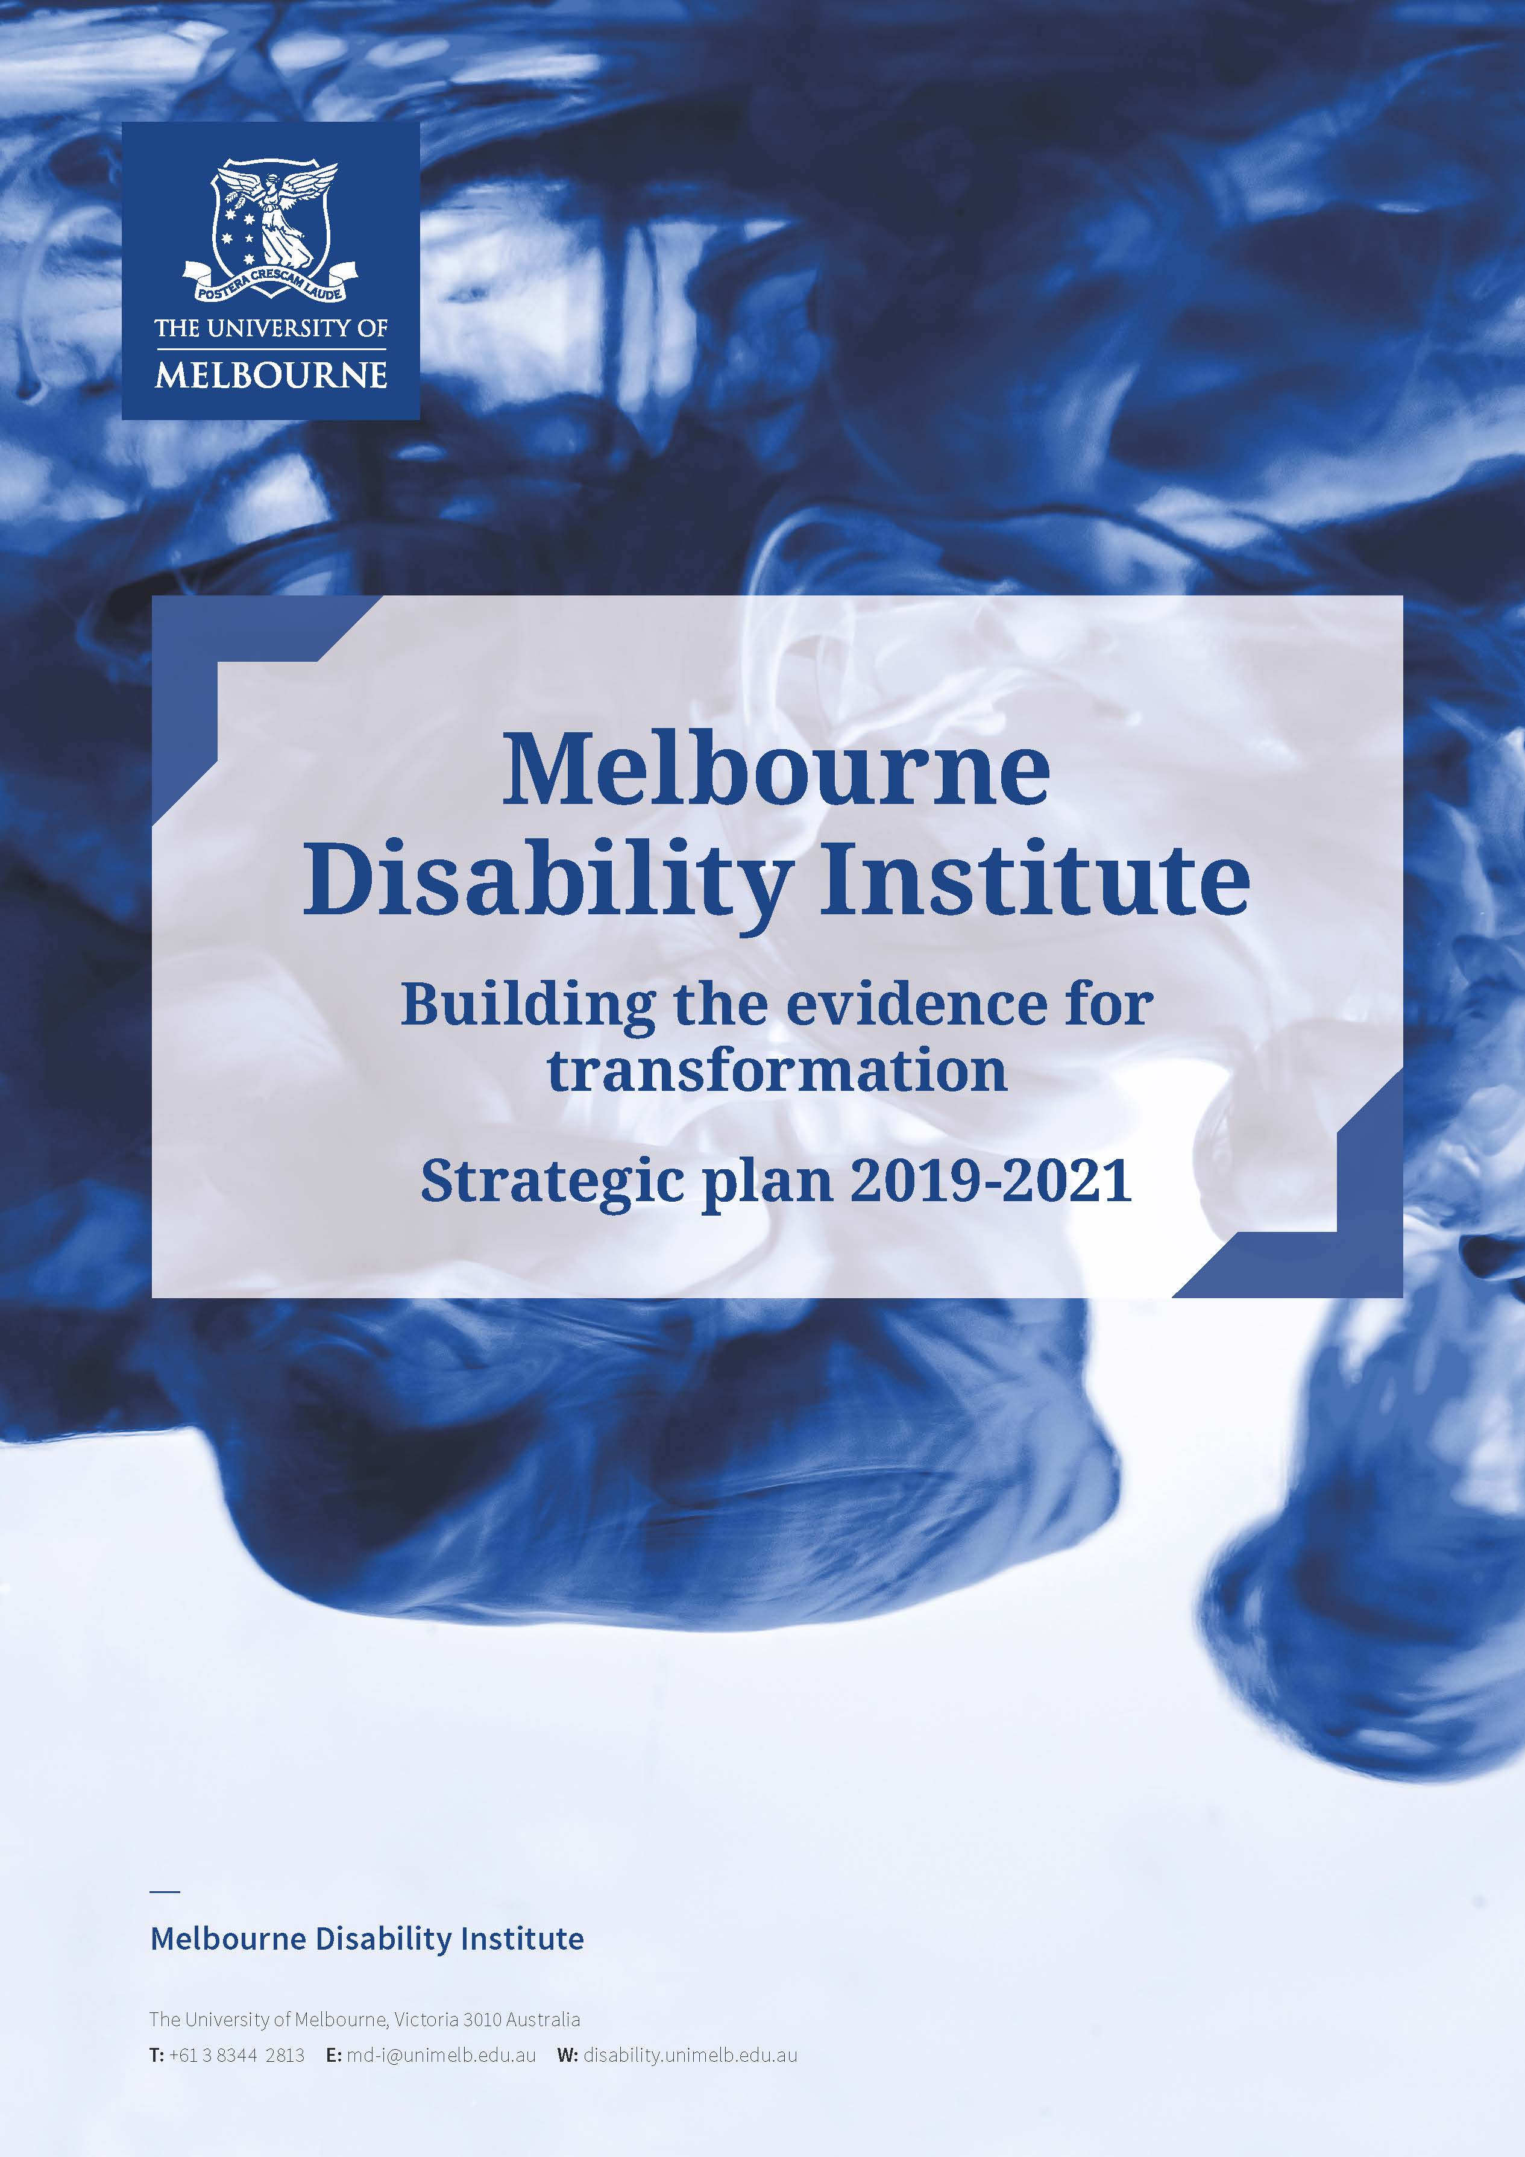

Table of contents
Melbourne Disability Institute 1
Vision 3
Mission 3
Executive Summary 3
Conceptual approaches 4
Strategic themes 5
Foundation principles 6
Democratising Disability Data 7
Approach 7
Strategy 2018-2020 8
An inclusive University 10
Governance and Management 10
Contact 11

Vision | To transform the social and economic wellbeing and the health of people with disability through high-quality research and translation, teaching and training.
Mission | In partnership with key stakeholders, we will be a catalyst for interdisciplinary research and teaching that addresses complex, systemic and cultural barriers facing people with disability, their families and carers. The knowledge produced through our research will be translated into policy and practice through a process of continuous engagement and innovation.

Executive Summary
The Melbourne Disability Institute (‘MDI’) was established in 2018 following major reforms that are transforming the lives of people with disability, such as the National Disability Insurance Scheme (‘NDIS’) and the National Disability Strategy 2010-2020.
The MDI brings together academics, businesses, government, non-government organisations, service providers, people with disability and advocacy bodies to build a collaborative, interdisciplinary and translational research program.
Ultimately, the MDI research program aims to capitalise on national reforms and active partnerships with the disability sector to deliver evidence for transformation. The MDI research program is centred around providing much-needed data for the disability sector and broader community to address the complex problems facing people with disability, their families and carers.
The MDI research program is underpinned by four foundation principles: data; interdisciplinarity; experience-based co-production with people with lived experience of disability; and active partnerships. The MDI will facilitate research through seed funding, research translation funding and community grants, in addition to leading several flagship projects in response to priority issues raised by the disability sector.
The MDI is housed within the University of Melbourne, building on established programs and partnerships, including the Scope-University of Melbourne partnership, the Hallmark Disability Research Initiative and the National Health and Medical Research Council (NHMRC) Centre of Research Excellence in Disability and Health.
This strategic plan outlines the MDI vision, mission and strategy for 2019-2021.

Conceptual Approaches
The Melbourne Disability Institute draws on several conceptual approaches to inform our work.

Capability approach
The capability approach, developed by Sen and Nussbaum, is concerned with ensuring that people with disability are able to live a life they value and have reason to value. Fundamental to the capability approach is the agency of an individual and the opportunity given to that individual to exercise that agency. Agency can be thought of as the individual characteristics and the resources a person has, or can develop. Opportunity refers to the environment an individual is in, enabling them to exercise agency. In an environment where an individual is empowered with the capacity and freedom to exercise their agency, they will be more likely to be able to pursue a life they value.

Human rights and active citizenship
We also draw on human rights approaches as enshrined in the United Nations Convention of the Rights of Persons with Disabilities (UNCRPD) to which Australia is a signatory. The UNCRPD outlines the rights of people with disability with specific reference to full and equal enjoyment of rights, dignity and fundamental freedoms and full inclusion and participation in their community. These principles give rise to the notion of active citizenship. Active Citizenship requires three conditions: self-determination, participation and contribution. This means people with disability have the freedom to choose and exercise autonomy, participate in all forms of life, including economic, social, political and cultural life, and contribute to society in meaningful ways so that their contribution is valued and their dignity is upheld.

Critical realism
The MDI supports the use of critical realism, an approach to disability described by Tom Shakespeare which conceptualises disability as a relationship between both the intrinsic factors of an individual, such as severity of impairment and attitude, and the extrinsic factors arising from the environment they find themselves in. This approach moves away from ‘defining disability as a deficit or structural disadvantage’ due only to an individual’s interaction with society and towards a more holistic approach, seeing disability as a result of both the experience of living with an impairment and navigating within society.

Integrated knowledge translation
Integrated knowledge translation is a model of collaborative research, whereby researchers work in partnership with knowledge users who have the authority to implement the research recommendations. Collaboration principles apply throughout the research process. Knowledge users bring unique expertise to the research process, including a deep understanding of the context and the potential for implementation. Researchers bring methodological and content expertise to the collaboration. Central to this approach is the sharing of power, partnerships that are established from the outset and active commitment to collaboration.

Strategic Themes
The MDI’s research is organised within five strategic themes.
- Opportunity and equity
All people with disability should have equal opportunity to access what they need to enjoy fulfilling lives. This theme seeks to ensure equitable access to justice, inclusive education, meaningful employment, intervention and support, and mainstream services.
Research supported by the MDI under this theme will aim to improve outcomes for disadvantaged groups including Indigenous Australians, people living in remote and rural communities, and people with complex needs including those with co-morbidities, mental health problems, and those not eligible for the NDIS.
- Inclusive Communities
All people with disability should have the opportunity to be involved in their community and participate in society. This theme focuses on the structures and practices that increase the inclusion of people with disability into everyday activities; including broader contexts such as home, education, workplaces and cities.
Research supported by the MDI under this theme will explore the role of services, families, relationships, advocates and volunteers in making communities more inclusive. Projects will aim to build capacity of communities to enable social inclusion and participation of people with disability.
- Health and well-being
Themes one and two focus on equity and inclusion, which underpin a meaningful and fulfilling life. This third theme focuses on other aspects that contribute to a person’s health and well-being, such as social determinants, lifestyle, unique health needs, child health, mental health, sexual and reproductive health, biomechanics and rehabilitation. The role of music and creative arts in enabling well-being also fall within this theme.
Research supported by the MDI will focus on the intersection between disability and health, reducing health disparities and addressing gaps that leave people with disability underserviced by the National Disability Strategy, the NDIS and the health system.
- Markets and sustainability
The introduction of the NDIS is creating opportunities for research into smart and ethical technology, effective market design, new models of service delivery, best practice approaches to consumer-directed models of technological and service development, and niche industries.
Research supported by the MDI will include economic modelling, commissioning by governments and individuals, exploration of disability services markets including the identification of ‘thin markets’ and new market opportunities, evaluation of innovative services including start-ups, and good policies and regulations for safeguarding people with disability and those who care for them.
Other projects will focus on the promotion and sustainability of a high-quality disability service workforce and innovative approaches to data collection.
- Policy and practice
All research auspiced and promoted by the MDI will seek to optimise policy and practice. This theme focuses on the best approaches to incorporating evidence into policy and practice so that we can transform the lives of people with disability, families and carers for the better. This will include promoting research approaches where key stakeholders, particularly people with disability, play a crucial role in identifying questions, interpreting results and driving change through innovative approaches to dissemination.
An integrated knowledge translation approach will build dynamic partnerships with local and state governments, the National Disability Insurance Agency, the Commonwealth, State and local governments, foreign governments, Disabled Peoples Organisations, key service providers, social insurers and others, to ensure research findings are taken up and integrated into policy or practice.
The MDI will incorporate a range of innovative approaches including media, leveraging partnerships, making submissions to inquiries and participating in public debate, to support academics and the sector to advocate for change and build the sector’s research capacity. The MDI is committed to bridging the gap between what is known and what is implemented.

Foundation Principles
The MDI is committed to four foundation principles that will underpin all activities:
- Data driven: data is central to all aspects of the MDI. The collection, ethics, privacy, linkage and analysis of quantitative and qualitative data are our tools for change.
- Interdisciplinary research: integrating disciplines, theories, methods and perspectives to advance fundamental understanding and responses.
- Experience based co-production: embedding meaningful co-production with people with lived experience of disability in all activities.
- Partnerships: with governments and the disability sector including advocates, service providers, social insurers, and business and philanthropy, both in Australia and globally.

Impact
The MDI strives to maximise the scale and impact of initiatives. Strong connections and partnerships provide links and pathways for ensuring research outcomes are taken up and result in a practical impact where it matters most.

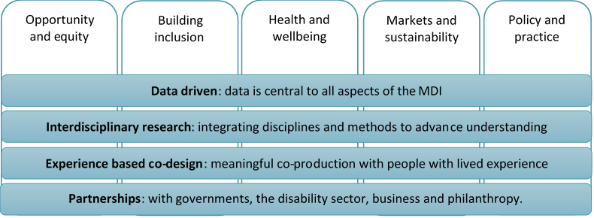

Democratising Disability Data
The MDI auspices a coalition of Australian researchers and stakeholders in the disability sector committed to achieving safe and secure access to disability data and statistics and linking that data safely and securely to other key datasets. The aim of the coalition is to provide the evidence needed to optimise services and policy to facilitate better lives of Australians with disability, their families and carers.
The Coalition’s aim is to build unity and champions across the disability and academic sectors in relation to democratising disability data. Initiatives include improved access to datasets; integration of multiple survey and administrative data through approved agencies; monitoring of social, economic and health outcomes for people with disability using routine data; discussions about digital and data opportunities; and discussions about safeguarding, ethics and consent.
Partnerships with Australian and international universities, state Governments, the Australian Bureau of Statistics, the Australian Institute of Health and Welfare, and numerous data custodians are central to this work. The initiative also builds on the University’s investment in Big Data across the campus.
Visit our website at disability.unimelb.edu.au/research/democratising-disability-data to sign up to the Coalition and stay up to date with progress.

Approach
The MDI intends to achieve its goals by:
- Building institutional capability in disability research by catalysing, facilitating, promoting, and acting as ‘match-maker’ for research activity and new collaborations.
- Supporting interdisciplinary research that aligns with the MDI’s goals and values, incorporates meaningful partnerships with the disability sector and will result in a direct benefit to people with disability, their families and their carers.
- Actively generating increased external income for disability research and increasing the profile of disability research across the University.
- Building capacity of people with disability through training, employment and scholarships, and through a community research academy that will upskill people with disability so they can be employed on research projects as community researchers.
- Developing productive partnerships with Australian and international universities, community organisations, governments, service providers and business groups in the area of disability.
- Contributing to the development of best-practice disability programs and policies at the University of Melbourne and in the higher education sector more broadly.
- Providing a point of focus for external engagement on disability and inclusion, which highlights existing and emerging skills knowledge and resources that are distributed across the University.
- Using our position to drive integrated knowledge translation and influence public debate to ensure the research outcomes impact on practice and policy.

Strategy 2019-2021

Facilitating Disability Research
The MDI is committed to facilitating disability research that is interdisciplinary and can demonstrate significant impact on the wellbeing of people with disability, their families and carers. We welcome approaches from University of Melbourne researchers, and from the disability sector including advocacy groups, government and service providers to partner with us and collaborate on projects of mutual interest.
Research funding will be allocated through four streams:
- MDI Flagship Projects
Collaborative Flagship Projects are designed in response to issues raised by the disability sector to address challenges facing people with disability. Flagship Projects enable the MDI to be responsive to new opportunities in a rapidly changing sector. These projects are usually of a larger scale and involve interdisciplinary research teams.
- Community Grants
The Community Grants scheme provides support for projects run by community-based organisations that build social capital. For example, a project may utilise evidence to improve services or a practice that can be replicated and shared, or to evaluate a program that improves lives of people with disability, their families or carers.
- Seed funding
Seed funding is intended to support pilot or discovery research that falls within the five strategic research themes. Funding will support innovate, interdisciplinary research that is likely to improve the lives of people with disability, their families and carers, and shows significant potential for impact or further funding.
- Research translation funding
The MDI recognises that project funding often doesn’t support active translation of research findings beyond publication. To address this, academics can apply for funding to augment an existing project that would benefit from additional time or resources to enable the effective translation of findings into policy or practice.
The MDI team aims to provide flexible and responsive support to suit projects, which may involve shaping research ideas, increasing a project’s impact, building internal and external partnerships, providing resources, seeking sustainable funding sources and providing project management or knowledge translation support.
Ongoing project management, funding and networking support

Capacity Building
The MDI will build capacity for disability research through training programs, networks and mentoring. By providing the data to address complex issues we hope to attract and develop some of the brightest minds. The MDI is committed to building capacity of academics, the disability community, policy makers and service providers.
We will also share our deep practical and conceptual understanding of disability and public policy, so that the expertise provided from those outside of the disability field working in partnership with us will have maximum impact on the lives of people with disability, their families and carers.

- Doctoral students
The MDI will support doctoral students with a disability or with a research interest in disability through scholarships, top-up scholarships and an annual capacity building program. Doctoral students will benefit from peer learning, mentoring and will build connections to the disability sector. The program will help position students’ work within the broader landscape of disability, encourage students to think in an interdisciplinary manner, and upskill them in communicating their research effectively.

- Community researchers
The MDI is committed to meaningful experience-based co-production which includes those with lived experience of disability in all aspects of the research program. A Community Research Academy will be designed for people with disability to learn the knowledge and skills required for effective peer research and provide opportunities for paid positions on project teams. All research auspiced by the MDI will involve people with disability as experts.

- Early and mid-career researchers
A community of practice will be established to provide informal and responsive support to early and mid-career researchers working in the field of disability. The community of practice will facilitate opportunities for networking, professional development, and access to relevant knowledge users including policy makers and service providers. A local exchange program will be designed to develop relationships between researchers and policy makers or people with disability, aiming to increase the relevance and uptake of research.

- Program evaluation
Service providers and other program planners in the disability sector are often faced with the task of having to evaluate a program to establish its effectiveness, improve its outcomes and seek ways of ensuring success and sustainability. Program or service evaluation is particularly relevant with the introduction of the NDIS and identifying best practice service provision is critical to success. The MDI will facilitate a training program to build capacity for evaluation within the disability sector.

Linkage and Partnerships
The MDI could not achieve its goals without strong partnerships with academics, the disability sector, governments, business and philanthropy. Some of the partnerships and key relationships that underpin the MDI program of work include:
- Peak bodies such as Australian Federation of Disability Organisations (AFDO), People with Disability Australia (PWDA), Carers Australia, National Disability Services (NDS), Alliance20 and Mental Health Australia;
- Disability People Organisations, Disability Advocacy Organisations, and family advocacy and support groups such as Victorian Advocacy League for Individuals with Disability (VALID) and Disability Advocacy Network Australia (DANA);
- Disability service providers and not-for-profits such as Scope Australia, the Brotherhood of St Laurence, Yooralla, Summer Foundation and Autism CRC;
- Local, state and federal governments; and
- Other universities and research institutes in Australia and internationally.

An inclusive University
The University of Melbourne is committed to access and inclusion and already has many projects underway to make the University campus more inclusive. The MDI will work closely with Chancellery and other groups across the University to progress a strategic framework aimed at improving access and inclusion. This will include contributing to the accessibility of new buildings, improving access to existing buildings, implementing better wayfinding, designing inclusive communication, providing information on hosting accessible events and ensuring centralised support for staff as well as students.
Education and disability awareness at the University of Melbourne will be enhanced through disability breadth subjects and by auditing courses with the aim of ensuring every student graduates with an understanding of disability.

Governance and Management
The MDI is one of six Melbourne Interdisciplinary Research Institutes (MIRIs) at the University of Melbourne. The MDI is supported through strategic investment by the Deputy Vice-Chancellor (Research) and reports to the Pro Vice-Chancellor (Research Collaboration). The MDI is housed within the Melbourne Graduate School of Education.

 | 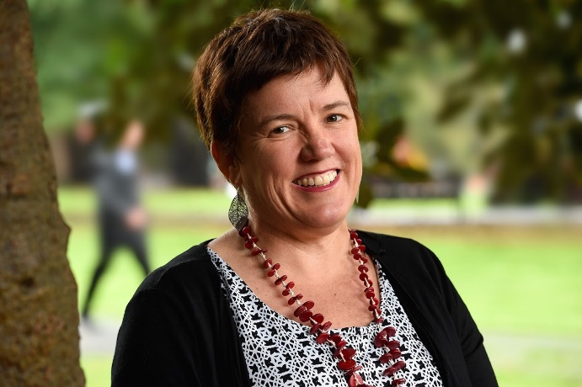
Professor Bruce Bonyhady AM  Executive Chair and Director  Bruce was the inaugural Chair of the NDIA and one of the key architects of the NDIS. | Professor Anne Kavanagh  Academic Director  Anne is an epidemiologist who has recently also been appointed to a new Chair in Disability and Health.

Establishment Committee
The Establishment Committee is the initial governing body for the MDI, advising on strategic direction and priorities from January to December 2018. The Establishment Committee consists of academics from law, public health, education and arts.

Executive Committee and Advisory Board
From 2019, an Executive Committee will be established to manage the ongoing direction of the MDI and advise on operational activities, engagement, research priorities and MDI-driven Flagship projects.
An Advisory Board will be established to ensure that research and other activities supported by the MDI is highly relevant and aligned with important, contemporary social issues and will provide leadership in the MDI securing additional funding. Members of the Advisory Board will have a diverse range of strong credentials in the public, private, philanthropic and disability sectors.

Contact
Melbourne Disability Institute  The University of Melbourne  Victoria 3010 Australia | Tel: +61 3 8344 2813  Email: md-i@unimelb.edu.au  Website: disability.unimelb.edu.au

National Disability Insurance Scheme https://www.ndis.gov.au/index.html
Department of Social Services National Disability Strategy https://www.dss.gov.au/
Sen, A. (1980) Equality of what? in: S. McMurrin (Ed.) The Tanner lectures on human values (Cambridge, Cambridge University Press). Nussbaum, M. C. (2000). Women and human development: The capabilities approach (1st ed.). Cambridge: Cambridge University Press
The Convention in Brief
Shakespeare, T. Disability Rights and Wrongs Revisited 2013 Abingdon: Routledge 296pp ISBN 978-0415527613
Kothari A, McCutcheon C, Graham ID; for the IKT Research Network. Defining integrated knowledge translation and moving forward: a response to recent commentaries. Int J Health Policy Manag. 2017;6(5):299–300. doi:10.15171/ijhpm.2017.15

