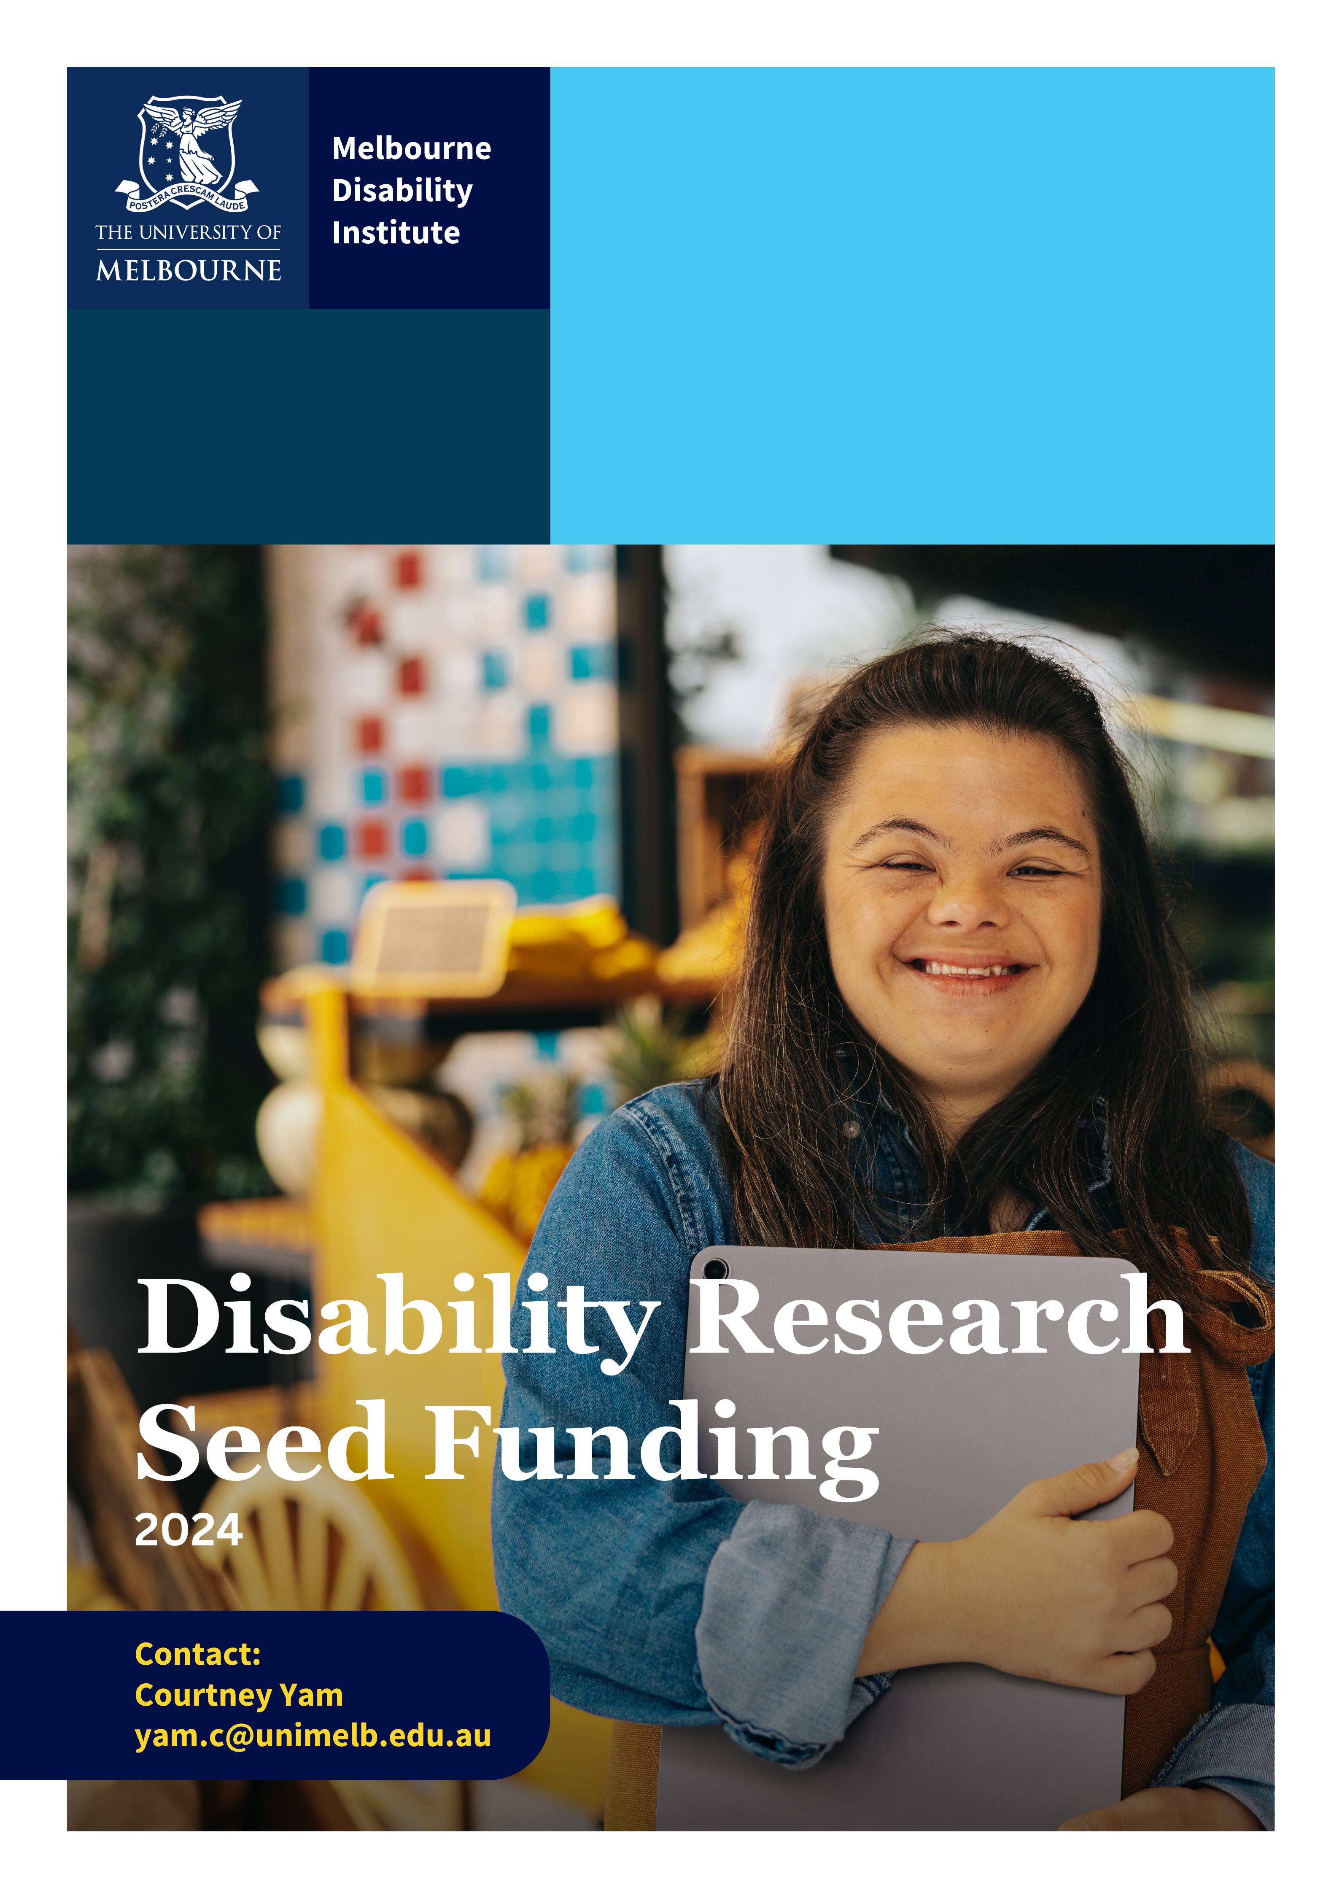

Melbourne Disability Institute
Seed Funding 2024

The Melbourne Disability Institute (MDI) runs an annual seed funding program to stimulate new collaborations between researchers from different disciplines and to build capacity across the campus in community engaged disability research.
Grants are aimed at small to medium sized projects at the discovery or pilot end of research.
To be successful, projects must address a topic of importance to people with disability, bring together researchers from different disciplines and must involve people with disability and/or their organisations in all aspects of the research process. We also look for projects that will have practical outcomes as well as a pathway to further research and funding.
Seed Funding Guidelines | We are looking for projects that:  - are driven by the priorities of people with disability,  - have practical outcomes,  - are interdisciplinary*,  - involve strong partnerships with people with disability and/or their organisations, and  - have a pathway to further research and funding.
*Please note, “interdisciplinary” means the project team must consist of researchers from at least two different faculties.
Applicants must have a salaried academic position of at least 0.4FTE at the University of Melbourne. Project teams must be led by the applicant, but can include external partners, graduate students, honorary or casual researchers. Project funds will be transferred at the beginning of 2025 and must be spent in the 2025 calendar year.
Applicants may apply for up to $35,000 for projects that meet our criteria. Weighting will be given to projects with a focus on working with First Nations or culturally and linguistically diverse people with disability, people with an intellectual disability and project teams led by early or mid-career researchers.
We encourage you to review the following guidelines and selection criteria closely and check your eligibility and timeline for applications.
Applications are due by 5pm on 30 October 2024.

Selection Criteria
- Clear evidence that the project is driven by the priorities of people with disability and/or families and addresses an evidence, policy or practice gap
- Genuine involvement of people with disability and/or families in all aspects of the project
We are looking for projects that are led by people with disability and/or conducted by and with people with disability. This will include shared decision-making, appropriate support to facilitate full participation, and appropriate payment.
- Policy or practice outcomes
We want to know how the knowledge generated by the project will have a positive impact on policy or practice. We want to know how the findings of the project will be shared and used.
- Robust methods
We are looking for projects that use methods appropriate to the question, are feasible with the resources available, and can be completed within a reasonable timeframe. We are also looking for evidence of a plan for how the next stage of the work will be funded and completed.
- Collaborative and interdisciplinary
We are looking for projects that involve genuine partnerships and reach across traditional disciplines.
- Addresses a focus area
Weighting will be given to projects that work with First Nations or culturally and linguistically diverse people with disability, or people with an intellectual disability. Priority will also be given to project teams led by early or mid-career researchers.

We are looking for projects that:
- are driven by the priorities of people with disability and/or their families
- have impact on the lives people with disability and/or their families
- include people with disability throughout the research process, including identifying questions and conducting the research
- address a clear gap in policy or practice
- are collaborative and build interdisciplinary research capacity
- have a clear and effective knowledge translation strategy
- have a rigorous method
- have a feasible scope and budget
- are able to scale and likely to obtain future funding.
Supporting bold ideas that can translate into better solutions | MDI seed grants provide funding to support interdisciplinary, community engaged projects in the early discovery, design or pilot stages of research.  We understand that building genuine collaborations and partnerships takes time and resources. That is why we prioritise the very early stages of project design and implementation – including genuine co-design of research questions and the building of partnerships and research teams that include people with disability, their families and representative organisations.  The outcome of a seed funding project does not have to be a finished piece of research – it can be the creation of a collaboration or partnership which will carry out a research project in the future. However, applications should clearly outline the future pathway for the collaborative research team, including feasible funding opportunities.  For example: in a previous seed funding round, MDI funded a project which consisted of a serious of roundtables where researchers worked with people with disability, their families and representative organisations to identify what research was needed, how it could be best conducted and to build the partnerships necessary to carry it out successfully. This project has led to an ARC Linkage grant application that was strengthened through the relationships and insights gained during the seed funding project.

Application Process
You can apply for seed funding using Microsoft Forms: https://forms.office.com/r/cjveMVfMK4
We have tried to make the application process as simple and accessible as possible. If you find any part of the process difficult, please contact MDI’s Program and Projects Manager Courtney Yam at yam.c@unimelb.edu.au. We appreciate all feedback.

Key Dates
The 2024 round will be open for six weeks. We will hold a small number of drop-in sessions either on Teams or in person to answer questions or discuss research proposals. Applicants can discuss their ideas, get connected with other academics or organisations who are interested in the topic or receive clarification on the application process and selection.
Important dates:
- Applications open Thursday 19 September 2024
- Drop-in sessions Book here: https://calendly.com/yam-c/2024-seed-funding-drop-in-sessions
- Applications close Wednesday 30 October 2024
- Applicants will be informed of the outcome of their application in late November
- Funding will be transferred in January 2025

Application summary
Below is a summary of the questions you will find on our application form.
Please note applications will be accepted via Microsoft Forms.
If you have any questions or are not able to submit via Microsoft Forms then please contact us.
- Project title
- Lead researcher – title, qualifications and expertise relevant to this project
- Other team members – titles, qualifications and expertise relevant to this project
- Brief description of the project
- How does this project address the priorities of people with disability and their families?
- What is the policy, research or practice gap being addressed by this project?
- How will people with disability and their families be involved in this project?
- How will the knowledge gained from this project be used?
- What is the methodology for this project?
- How will this project bring together researchers from different disciplines and/or external partners?
- Please provide an outline your project budget.
- When this project is finished, what is the next step? How will the collaboration continue, or will further research be carried out?
- Is there anything else you would like MDI to know about this project?

Seed Funding Terms and Conditions
- Melbourne Disability Institute
  - The Melbourne Disability Institute (MDI) is an interdisciplinary research institute at the University of Melbourne.
  - MDI facilitates and funds innovative interdisciplinary research designed to address the complex problems facing people with disability in Australia. It aims to ensure the University of Melbourne is a national and international leader in community engaged disability-focused research.
  - MDI receives funding through the Deputy Vice-Chancellor (Research).
  - To further research and support interdisciplinary collaborations across the University, MDI provides seed funding for interdisciplinary projects at the discovery or pilot phase of research. Interdisciplinary is defined as cross faculty in order to meet the requirements of our funding from Chancellery.
  - The seed funding is administered by MDI in accordance with these terms and conditions.
  - MDI staff will provide appropriate guidance, support and assistance to researchers to facilitate the successful completion of projects.
- Project Selection
  - To be eligible for consideration, researchers must submit an application form.
  - The application forms will be evaluated by MDI’s review panel. The review panel will consist of MDI staff, researchers from across the University of Melbourne as well as at least one external party.
  - The selection criteria are evenly weighted. We are looking for projects that:
    - Provide clear evidence that the project is driven by the priorities of people with disability and/or families and addresses an evidence, policy or practice gap
    - Involve people with disability and/or families in all aspects of the project
    - Have clear outcomes and will have an impact on policy or practice
    - Have robust and appropriate research design and methods, are feasible with the available resources and have a plan for future sustainability
    - Are collaborative and build interdisciplinary research capacity
  - Following the evaluation, the MDI selection committee will:
- Approve the proposal;
- Reject the proposal;
- Seek additional information; or
- Request resubmission of an application.
2.5 The decisions of the selection committee are final.
2.6 MDI may consider an out of round application in exceptional circumstances.
- Funding
  - Funding amounts are at the discretion of MDI.
  - Funding can be used for:
    - researchers
    - accessibility and inclusion costs - such as Auslan interpreters or captioning
    - costs associated with external collaborators – particularly community-based partners or payments to people with disability participating in research
    - consumables
    - access to data
    - data
    - research translation costs – such as the production of Auslan videos or Easy English materials
  - Any questions regarding use of the funding, including what can be purchased, should be directed to MDI.
  - Any assets purchased and unused funds remaining at project completion are to be returned to MDI.
- Researchers and eligibility
  - Researchers are University of Melbourne staff working on the project.
  - All projects must nominate a Lead Researcher who has a salaried academic position of at least 0.4FTE at the University of Melbourne.
  - Project teams must be led by the Lead Researcher, but may include external partners, graduate students, casual or Honorary researchers.
  - Project teams must be interdisciplinary. This means that resarchers from across two different faculties should be involved in the project.
  - Seed funding is not intended to fund graduate research. Applications from graduate students will only be considered in exceptional circumstances and where an appropriate supervisor has already been identified.
  - Researchers associated with funded seed projects are regarded as an important part of MDI’s research community. They are:
- Invited to participate in research activities associated with MDI
- Encouraged to join the MDI Community of Practice to link with other researchers across the University of Melbourne
(b) Entitled to refer to themselves as an MDI researcher while they are active on their funded project.
  - All researchers must disclose any real, potential or perceived conflicts of interest.
  - All researchers must provide timely responses to requests from MDI staff.
  - Researchers are encouraged to actively participate in the MDI’s activities, such as events, lectures, seminars and workshops.
  - In submitting an application, it is assumed that all researchers have consulted with their Head of Department and have the capacity to undertake the project.
  - Intellectual property is governed in accordance with University of Melbourne’s policies and procedures.
- External Collaborators
  - Staff working on the project who are not affiliated with the University of Melbourne are regarded as external collaborators.
  - All external collaborators must disclose any real, potential or perceived conflicts of interest in relation to the project.
  - Governance of external relationships and intellectual property is in accordance with University of Melbourne’s policies and procedures.
- Reporting
  - Researchers must provide two reports to MDI – one at the completion of the project and one a year after the project is complete. The reports must be completed on the MDI template.
  - Any delays to the project completion must be reported to MDI.
  - Researchers will also be asked to provide a plain language summary of their project and its outcomes. This summary will be:
    - Made available to members of the disability community on request
    - Published on the MDI website
    - Published in university publications such as newsletters
    - Published in the MDI Annual Report
  - Researchers may also be asked to provide an update on project progress on request.
  - Researchers must also agree to publish findings in an open and accessible manner in a format agreed to by MDI. Contributions to The Conversation and opinion pieces are encouraged to disseminate the findings widely.
  - Researchers must also provide MDI with details of any publications, conference papers and seminars, media coverage or additional grants arising from the project and for three years following the completion of the project.
- Communication
  - Researchers may be asked to present their work at MDI events and forums.
  - Researchers may be asked to provide project updates and outcomes as part of MDI’s communication and engagement activities.
  - Researchers are asked to reference MDI funding on all academic, general and media publications and work relating to or arising from the project.
- Revocation
  - Seed funding can be revoked for:
- Failure to adhere to any of these terms and conditions.
- Failure to commence within 6-months of receipt of funding.
- Provision of false or misleading information in the Seed Funding Application.

