Program overview
There are many creative and innovative programs and services being run by and for people with a disability in the Australian community. Many are developed and run by small organisations who often lack the time and resources to capture their impact, evaluate outcomes achieved or identify ways to further extend and strengthen their practice.
At the same time there is an increasing need for organisations to provide evidence of outcomes and impact, particularly to funders. Robust independent academic research can be helpful in capturing impact. It can also be useful to provide evidence to strengthen advocacy for change.
The Melbourne Disability Institute’s Community-Based Research Program aims to meet the research needs of community organisations by providing research support and evaluation for strength based and innovative programs that are making a difference in the lives of people with disability, their families and carers.
Research support provided through the program may include a scoping report, literature review, data analysis or a small evaluation project. Research can lead to outcomes such as improved service delivery, the development of new services, improved ability to advocate effectively or improved capacity to undertake future research projects.
The program is targeted at small to medium-sized community organisations that currently have limited capacity to conduct research. All research will be shared publicly, including where appropriate in academic publications.

We encourage people with a disability to help identify organisations who they think are providing valuable support and services, and to pass on the opportunity for them to apply.
How it works
- Organisations apply using our MDI Community-Based Research Program Form.
- Applications will be reviewed by a panel which includes people with a disability, researchers and experts from community.
- Up to five projects will be selected.
- Successful applicants will be matched with a University of Melbourne researcher with relevant expertise. The project will be conducted in conjunction with the successful organisation.
- When the research is complete, a final report will be delivered to the successful organisation. A further publishing grant can be requested by the research team to support publications in academic journals.
Want to know more?
Read through this information pack and visit our website to learn about previous Community-Based Research Projects:
https://disability.unimelb.edu.au/#current

Community Based Research Projects
MDI and the University of Melbourne researcher will work hand-in-hand with the community organisation to help design a feasible project that fits available resources and timeframes. This may include such activities as:
- An initial workshop or kick off meeting to understand the program and its context
- A review of relevant academic literature to help frame the research and provide an overview of the state of current knowledge
- A customised research plan - including Ethics applications where necessary
- Collection of data through such activities as surveys or interviews
- A meeting to discuss findings and what they mean for the organisation
- A plain language report and a visual summary (infographic) where applicable
- Participation in an end of year presentation held at MDI
Project details
MDI will pay University of Melbourne researchers up to $15,000 per project. The size of the research project will depend upon:
- The needs of the community organisation
- How easily and quickly community organisations can organise participants in the research
- How many students and/or research assistants are involved
- How intensive data collection is likely to be – for example transcribing interviews takes additional time
Payments for people with a disability
MDI expects every aspect of the project will include people with disability, from conception through to the final report.
We expect co-researchers and participants to be paid appropriately. Additional funds (up to $2,000) are available to pay participants for their time. This funding can be requested by the community organisation or by the researcher.
Publication grants
Publication in academic journals can not only add to the body of evidence in a particular area but can also help build an evidence base for innovative programs and services.
Additional funding (up to $2,000) is available for researchers to assist with the costs of publication. Researchers must submit an additional application for this funding once the project is complete.

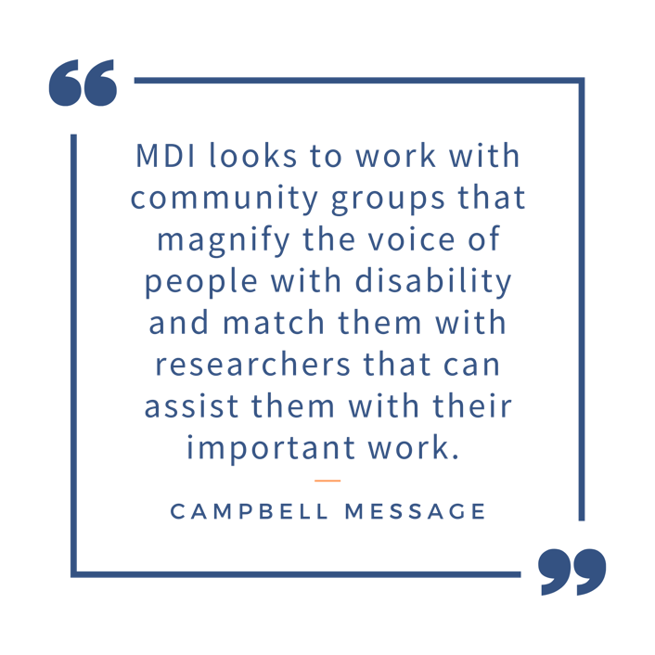

Eligibility
MDI invites applications from organisations who provide support or services for people with disability, their family or carers, to live engaged, self-directed and fulfilling lives.
It is essential that people with disability (and families where appropriate) are involved in the research process, including the project proposal
To be eligible for the MDI Community-based Research Program your organisation must:
- Provide support or services to people with a disability, their family or carers.
- Be of small to medium size (less than 200 employees)
- Have limited capacity to conduct research
- Can be based anywhere in Australia. Please note however the work needs to be able to be completed from Melbourne. Interstate travel is not funded.
- Include a statement how people with a disability, their family or carers are involved in your organisation, and how they will be involved in the research project.
Innovative programs that fall outside these criteria may be considered. Applications should however tell us why this research will help people with disability and why it cannot be funded through other means. Applicants should also contact the Program Manager to discuss prior to submission.
Selection criteria
Applications will be assessed on the following criteria:
- The program to be evaluated or research aims to build the capacity of people with disability, their family or carers to live engaged, self-directed and fulfilling lives.
- People with a disability (and/or families where appropriate) are involved throughout the research process, including establishing the research idea.

- Leads to knowledge that can be used by the community organisation as well as other organisations.
Successful applicants will be matched with a University of Melbourne researcher. MDI and researchers will work together to design and implement the research project.
Award and use of funding
- Research can only be completed by University of Melbourne researchers.
- Research and evaluation must be completed within 12 months.
- Funding will be provided directly to researchers involved in the project.
- A small amount of funds (up to $2000) may be requested by the organisations or researchers to assist paying for people with a disability to be involved in the research and research process.
- Grants will be awarded for new research only and not for deficit financing of existing research.
Reporting requirements
Successful applicants will work together with the researcher and MDI to produce a report and visual summary that captures findings and key learnings. All successful applicants must agree to the open and accessible publishing of any findings.
All Community-based Research Program recipients will be given an opportunity to share their project and what they have learnt with the broader disability community in our yearly showcase.

Key dates
Applications open: Tuesday 8th March
Applications close: Wednesday 20th April
Notification of outcomes: Wednesday 4th May
Application
We recommend calling or emailing Program Manager Campbell Message to discuss your idea and make sure it meets the program’s objectives before submitting an application.
Please note the project size before applying – projects that are too large will not be considered.
Download the application form at disability.unimelb.edu.au/home/funding/community-based-research and submit to campbell.message@unimelb.edu.au
The application process is designed to be as simple as possible. Responses to questions are expected to be brief (less than 200 words). And dot points are just fine!
Applications close at 5pm on Wednesday 20th April.
Assessment
Each application will be assessed against the eligibility and selection criteria outlined above.
Contact
If you have any questions about the program or the application process, please contact:
Campbell Message
Program Manager
Melbourne Disability Institute
e. Campbell.message@unimelb.edu.au
p. +61 3 9035 7775

